

STATEMENT OF WORK

Integration of Radiology into Agfa HealthCare’s Enterprise Imaging 8.0.x

#### Prepared by Agfa Healthcare for:

#### South Texas Radiology Group (STRG)

#### Date: 10 March 2016

Prepared by:

Bill Turlik, MSCIS, Workflow Architect / Service Transition

Kathy Beard, Release Manager / HE

|  |  |  |  |  |
| --- | --- | --- | --- | --- |
| Version History (in reverse order) | | | | |
| Version | Date | Author | Status | Comments |
| 1.0 | 2016/2/19 | B. Turlik, K. Beard | Draft | First Draft based on internal review |
| 1.1 | 2016/3/8 | K. Beard, C. Morris | Draft 2 | Replaced diagrams and added custom workflow. Removed installation of a separate MPI for STRG. |
|  |  |  |  |  |
|  |  |  |  |  |
|  |  |  |  |  |
|  |  |  |  |  |

**Table of Contents**

1 PURPOSE OF THIS DOCUMENT 4

1.1 Enterprise Imaging CSP (Workflow) Overview 4

1.2 Enterprise Imaging CWP (XERO) Overview 5

1.3 Enterprise Imaging Connect Overview 5

1.4 Enterprise Imaging Exchange Overview 5

1.5 Enterprise Imaging Business Intelligence 5

1.6 Enterprise Imaging Master Patient Index 6

1.7 Enterprise Imaging Teaching Files 6

1.8 GRIP Monitoring Overview 7

2 Solution Deployment 8

Enterprise Imaging Core Deployment 8

Consumer Portal 9

Reporting 9

Desktop Integration – Primordial 9

3 PROJECT ENVIRONMENT 9

3.1 Agfa Product Functionality 9

3.2 General Environment 9

Phase 1 – Project Initiation & Planning 13

Phase 2 – Review and Analysis 13

Phase 3 – Enterprise Imaging Build – Test Environment 14

Phase 4 – Enterprise Imaging Integration – Test Environment 14

Phase 5 – Enterprise Imaging Build – Live Environment 15

Phase 6 – Enterprise Imaging Integration – Live Environment 15

Phase 7 – Go Live 16

Phase 8 –Transition to Support / Project Wrap-up 16

3.3 Enterprise Imaging Services 16

4 PROJECT DELIVERABLES 22

5 Core Installation Service Description 22

5.1 Enterprise Imaging Business Analysis 22

5.2 Enterprise Imaging Core OVA Deployment (TEST) 22

5.3 Enterprise Imaging Component Software (TEST) 23

5.4 Enterprise Imaging OVA Deployment (PROD) 23

5.5 Enterprise Imaging Component Software (PROD) 23

5.6 Enterprise Imaging Component Installations 23

System Scaling 26

System Language 26

References 27

Solution Deployment and Data Flow Diagrams 27

Network Specifications 28

Licenses and Auxiliary Equipment 29

Connection to DICOM Modalities 29

Task-Driven Workflows 30

Training 30

Customer Managed Infrastructure Solution 31

Customer Managed Storage 32

Agfa Roles and Responsibilities for a Customer Managed Storage Solution 32

Ongoing storage integration services added into the service maintenance agreement (SMA) 32

Customer’s Roles and Responsibilities for a Customer Managed Storage Solution 33

Agfa Roles and Responsibilities for Customer Managed VMWare environments 34

Customer’s Roles and Responsibilities for Customer Managed VMWare Environments 35

Business Continuity 36

6 SOW ACCEPTANCE 59

# PURPOSE OF THIS DOCUMENT

Agfa HealthCare (“Agfa”) is the provider of the solution (“System”) and services to be delivered to South Texas Radiology (“Customer”) as described in this Statement of Work (“SOW”) Addendum. Sharing patient information, including clinical images and reports across the hospital enterprise, will improve the delivery of services, enhance quality of care, improve efficiency of care and allow for improved communication and collaboration among the Circle of Care providers. Successful integration will improve completeness, accuracy, relevancy and consistency of the imaging health record documentation. Finally, the solution will provide complete and legible access of clinical data at the point of care to support clinical decision-making.

This SOW defines project scope, environment, and responsibilities mutually agreed to by Customer and Agfa prior to project kickoff in order to guide delivery of the solution. Project phasing and project delivery timing are documented in the Project Plan, which is delivered to Customer after Project kickoff.

## Enterprise Imaging CSP (Workflow) Overview

Enterprise Imaging CSP (Workflow) is a client/server departmental solution. The key responsibility for Enterprise Imaging Workflow is to provide order and scheduling in Enterprise Imaging for any departments that do not currently have these capabilities, as well as act as an image manager for studies in progress. The Enterprise Imaging Workflow component will create and fill orders. Orders that are already filled can also be passed as well. Enterprise Imaging (CSP - Enterprise Imaging Workflow) assumes responsibility for reconciliation / QC Fix-Up, verification, DICOM Modality Worklist (DMWL), and DICOM MPPS.

The Enterprise Imaging Workflow core components are the:

**Database Management System**

The Enterprise Imaging Workflow Database Management System (“DBMS”) is deployed utilizing Oracle to provide, among other responsibilities, data indexing, and patient demographic information services for studies it manages.

**Application Server**

The Enterprise Imaging Workflow Application Server service hosts the primary business logic of Enterprise Imaging Workflow. All DICOM studies will be archived to the Enterprise Imaging VNA component. All Reports generated in Enterprise Imaging Workflow will generate a HL7 ORU message which will be converted into DICOM SR object by the Enterprise Imaging Verify component. All Orders filled by Enterprise Imaging Workflow will output a HL7 ORM when the study is received by the Enterprise Imaging Workflow component. Enterprise Imaging Workflow also includes the Enterprise Imaging Capture components that handle many digital Image/Video upload capabilities.

**Online Cache, PRIORS Cache and Nearline Archive Storage**

The Enterprise Imaging VNA Online Cache (Cache), PRIORS Cache (Cache), and Nearline Archive (“Archive”) storage tiers provide temporary and long term storage of data received by the SAS and indexed by the DBMS.

**Load Balancer**

A Load Balancer provides for load balancing across a highly available stateless two application server environment.

## Enterprise Imaging CWP (XERO) Overview

Enterprise Imaging CWP (XERO) provides reference Image and Report viewing in Enterprise Imaging. It provides a URL interface that EMR companies can launch to display the patient longitudinal record. Enterprise Imaging XERO can be accessed through common HTML5 browser or, by implementing APIs, embedded within host applications such as Clinical Information Systems, Electronic Health Records, and Web Portal Applications. XERO Exchange Network is configured for cross-system / location viewing of studies from 3rd Party Systems (PACS, C-PACS, IMS) via CWP (XERO) without having to store or archive the study.

## Enterprise Imaging Connect Overview

This component is the HL7 interface engine for Enterprise Imaging, and is responsible for handling all the HL7 message traffic in/out of Enterprise Imaging. Connect is required in all VNA-centric deployments of Enterprise Imaging. Enterprise Imaging Connect also handles all HL7 messages within the Enterprise Imaging systems. The one exception is the direct HL7 messages between Enterprise Imaging VNA and Enterprise Imaging Verify used for HIS Verification services. Connect will not be deployed in most CSP-centric configurations as BPE will handle the HL7 integrations, but may be added as an optional deployment.

## Enterprise Imaging Exchange Overview

This component allows external parties, such as peer hospitals, to upload foreign studies into the Enterprise Imaging solution. Studies coming through this method do not have accompanying orders; EI provides this workflow. The Image Exchange solution utilizes four components within Enterprise Imaging: the EI CSP workflow engine, the XERO® viewer, a secure internet tunneling application (Transfer), and a patient/Physician upload Portal.

## Enterprise Imaging Business Intelligence

Following use cases apply to the Enterprise Imaging BI end user:

* As an Enterprise Imaging BI author I want to be able to create and/or edit reports and/or graphs on data available in my Enterprise Imaging Server and/or Enterprise Imaging VNA databases.
* As an Enterprise Imaging BI consumer I want to be able to run reports and/or graphs on data available in my Enterprise Imaging Server and/or Enterprise Imaging VNA databases.
* 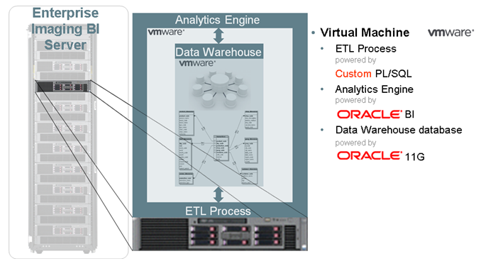

## Enterprise Imaging Master Patient Index

The Enterprise Imaging MPI (EIMPI) allows for the creation of an enterprise imaging patient identification domain that matches patients across sub-domains based on admissions information. The resulting enterprise imaging master patient domain presents a multi-patient-domain longitudinal imaging record that is accessible through Enterprise Imaging diagnostics (radiology, cardiology, etc…) and the XERO® enterprise viewer. Note: The EIMPI is limited-use license that create a master patient cross-reference domain for the for the Agfa solution. A full eMPI license (versus the imaging-centric EIMPI license) is available as an upgrade.

There will be a feed from the MPI directed to the STRG core in order to provide an enterprise level patient identifier.

## Enterprise Imaging Teaching Files

A end user can utilize teaching files for comparisons to current studies right within Enterprise Imaging’s powerful Hanging Protocols. Teaching files have flexible terminology sets and rich clinical data improve search for comparison studies, a dedicated web interface allows physicians easy access from mobile devices and PCs – no Diagnostic Workstation required, compliments XERO web platform enabling real-time visual web based collaboration between resident and attending physicians, and improves interoperability with support IHE Teaching File and Clinical Trial Export (TCE). Teaching files allows the user to flag images or studies, anonymize, tag with relevant clinical details, tag teaching files with multiple terminologies including anatomy, pathology, keywords. (future: Diagnosis, Differing Diagnosis, Findings, Organ System), include WEB/URL and other references in bibliography, and has support for standard terminology code sets (ACR, RADIex, SNOMED) and support for custom code sets.



## GRIP Monitoring Overview

Global Remote Incident Prevention (GRIP) Monitoring Services consists of; GRIP Monitoring System, GRIP Event Management, and GRIP Event Reporting. GRIP Monitoring can automatically detect potential incidents and prevent incidents from happening. GRIP allows AGFA to obtain better incident resolution times and improves uptime, minimizing disturbances to customers’ productivity.

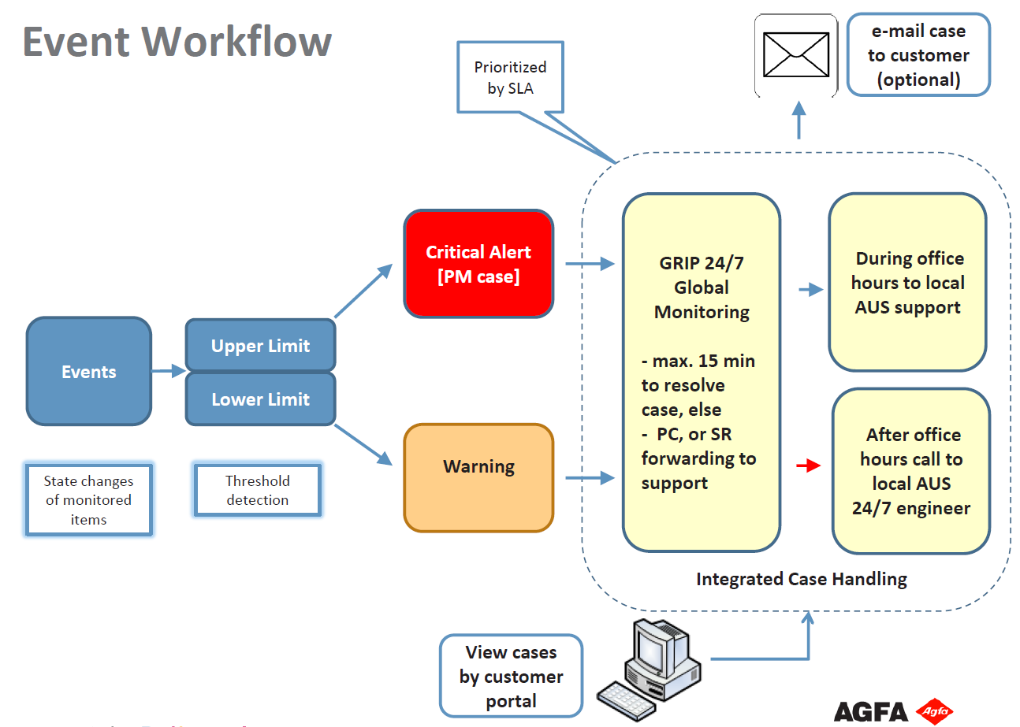

# Solution Deployment

## Enterprise Imaging Core Deployment

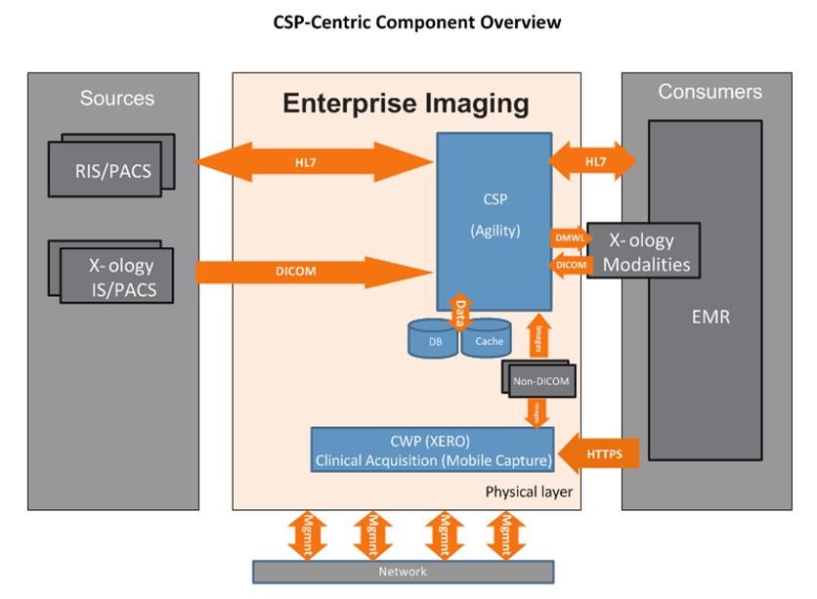

The Database server is the “database server component” for Enterprise Imaging and is the mandatory database system of Enterprise Imaging. The Database server will can be deployed on a Linux Operating System. The Oracle database server hosts a single instance Oracle database that contains all data model entities needed by the Enterprise Imaging solution. The CSP server is the “application server component” for Enterprise Imaging and is the mandatory system servicing the core functions of Enterprise Imaging. The CSP server will be deployed on a Linux Operating System. The CSP hosts the XIS, PACS, and workflow services for Enterprise Imaging. It also contains the business logic to support these services. Workstation deployments (such as Standalone and Standalone Premium)are deployed on Windows.

## Consumer Portal

Enterprise Imaging integrates with a separate MphRx file system (which is optionally packaged with Enterprise Imaging). Enterprise Imaging clients are able to upload DICOM and non-DICOM studies via a MphRx server located in a customer DMZ. The data is then sent to EI to be reconciled via an internal or external order. Uploaded data can be visualized from Enterprise Imaging desktops and XERO® universal viewer.

## Reporting

Enterprise Imaging has the Nuance Speech reporting engine embedded in Enterprise Imaging CSP (Workflow). This will allow a seamless reporting workflow for radiology and other multi-specialty use cases.

## Desktop Integration – Primordial

The functional details for this integration are yet to be developed. Agfa’s integration team will work with Methodist to define, test and implement integration software whereby the Enterprise Imaging client opens the Primordial client software. A detailed functional specification for the integration will be developed as one of the first steps of the project.

The accompanying Software Only Plus maintenance contract provides sustaining engineering of the integration as new releases of Enterprise Imaging are introduced. Integration modification required due to changes made to the Primordial product including upgrades, is not covered by the Software Only Plus maintenance agreement.

Note: This integration is currently released for controlled delivery. If this quotation results in the first customer order, a field validation to confirm the expected performance will be completed at the customer site. Coordination with development resources will need to be planned into the integration product delivery schedule.

# PROJECT ENVIRONMENT

This section describes the general environment this project shall be delivered within. If any of these general environmental conditions is not met, Agfa will evaluate the impact on the project, and if Agfa deems the resulting impact to be significant, the unfulfilled condition will be considered as a change in the scope of the project and Agfa will start a change control procedure.

## Agfa Product Functionality

Customer is aware that all Agfa products are governed by their specification documents (e.g. functional specifications, hardware requirements, compliance claims …).

## General Environment

* Customer provides access to all locations required for system installation, configuration and training.
* Customer provides remote access to network for Agfa through remote configuration and/or testing. All necessary Certificates (Web certificates – e.g. from firms like Verisign) required for security access, will be provided by Customer. A secure remote connection must remain available after go-live.
* Any required changes or modifications to the rooms and buildings where the System will be installed (such as cabling…) will not be performed by Agfa (see Technical services).
* The required IT infrastructure (including network) for the project is available for the duration of the project, and performs (during and after the project) according to the specifications as defined by Agfa. Customer is responsible for the compliance of the infrastructure with Agfa’s specifications.
* Customer is responsible for ensuring the network meets the minimum bandwidth requirements.
* Customer shall notify Agfa of any system, application, or equipment modifications known to be unique, deviating from industry standard, or potentially problematic. This would include, but is not limited to, unique testing procedures, naming conventions, user exits, local code modifications or custom implementation.
* Customer is responsible for all equipment and systems not installed by Agfa Healthcare.

### Network Infrastructure

* + Agfa is not responsible for any issues related to network site readiness, unless specifically called out in this Statement of Work. Customer shall ensure the network meets the minimum recommended bandwidth for this project.
  + Agfa’s products have been validated to perform to specification when the workstations/servers share a production VLAN and certain backend servers and storage have a separate storage VLAN.
  + Customer is responsible for providing the network infrastructure, unless Agfa has been asked to provide these services under a separate statement of work.
  + The site readiness review will include the network assessment.
  + A network assessment shall include details on the network topology, including domain, IP addresses, etc.
  + If requested Customer must provide a detailed network diagram in order to assist in ruling out networking issues during implementation and ongoing support.
  + Enterprise Imaging servers should operate on a gigabit network or greater for best performance. During joint discussions, it was agreed that 10 Gbps networking is warranted for some of the core components that will be handling image data flows. Agfa cannot and does not guarantee performance or functionality if the minimum network recommendations are not met.
  + It is presumed that the ESXi servers are connected to the network via trunked connections (802.1Q), and can thus have VMs running in both an intranet and DMZ subnets. This is required for Enterprise Imaging Transfer (it must run in a DMZ to receive data from outside the hospital environment) and Enterprise Imaging XERO.
  + Customer must provide secure remote access to Customer network for Agfa remote services support (Secure Remote Service System).

### Project Management

* + All change requests will be administered in accordance with Agfa’s change control procedures and forms, or in accordance with the procedures set out in the standard Terms and Conditions.
  + All change requests identified during the course of the project are not included in the solution scope as defined in this document.
  + If there is a change in functionality or in any of the project deliverables requested by Customer, the change control process will be applied.
  + Products ordered by Customer from other vendors that are needed for the system installation are delivered in/on time, as specified in the project planning.

### Customer Involvement

* + All necessary resources on behalf of Customer are available for the project, as indicated in the project plan.
  + Customer is responsible for enforcing the attendance of all trainees.
  + At the project kick-off meeting, Customer must designate a Customer project team.
  + Customer should provide an office or room for Agfa project personnel that is equipped with telephone and network access. Access to a facsimile machine is also requested.
  + All travel and lodging expenses on behalf of Customer or 3rd party resources are the responsibility of Customer.

### Clinical Analysis

* + During project initiation, Customer is responsible for providing Agfa with a complete description of the existing systems, including:
    - * Full and up-to-date details of the installed hardware and software (e.g. version numbers, IP addresses, admin usernames and password, …)
      * Complete and up-to-date description of Customer’s end-to-end workflow to be validated by Agfa.
  + During the project initiation, Customer is responsible for providing Agfa with all relevant information of all systems that the System interfaces with.
  + Customer is responsible for creating or assembling the information in the previous points if it does not yet exist.
  + Enterprise Imaging Business Analysis needs referenced in section 4.3 shall be considered as part of the Clinical Analysis

### Delivery and Installation

* Delivery and installation activities can only take place after the site-readiness acceptance milestone has been completed.
* Customer system administrator is available for the duration of the installation activities.
* Customer is responsible for providing secure storage for all delivered goods.
* Customer is solely responsible for all delivered goods after delivery.

### Integration

* + All external systems interfaces which need to connect to the Agfa system comply with the Agfa compliance statements for the relevant interface type. Any interface fields marked as ‘not Agfa supported’ in the compliance claim are subject to analysis. These fields will only be considered on a time and material basis and are outside the scope of this SOW.
  + Requests for non-standard interfaces are outside the scope of this SOW.
  + Custom integration work (due to, by way of example and not limitation, incompatibility of legacy data or the data being input into the Agfa system by Customer with the system’s specifications) is outside the scope of this SOW.
  + Customer is responsible for any third party vendor support and configuration costs, if required.
  + Customer is responsible for the storage, archiving, retrieval success, pre-fetching success and quality of the data once the data leaves the Agfa Interface.
  + Customer is responsible for providing all relevant information about the interfaces.
  + Customer is responsible for providing production representative sample test messages.
  + Customer is responsible for implementing/modifying, testing, and validating required interfaces on all third party systems.
  + Customer personnel are available to review and approve the interface specifications.
  + Customer personnel are available to participate in testing and validating the interfaces.

### Training

* + All trainees have adequate time available to attend the training sessions, without being required to fulfill their normal responsibilities.
  + The following equipment and infrastructure is available:
  + Dedicated training area.
  + Sufficient client PCs with specified software.
  + Training network access to test/production networks.
  + Training network attached document printer.
  + Any augmentation to the training schedule or number of training participants is subject to the project change control procedure.

### System Acceptance

Customer is responsible for ensuring that:

* + All external systems are available for the acceptance tests, as required for the smooth execution of the tests.
  + Sufficient resources from Customer or from the parties responsible for these systems are available to support the testing activities. These resources may be asked to use the external systems, initiate sending or receiving of messages over the interfaces, etc.

The items listed above must be available for the complete duration of the acceptance tests, as well as for the period of preparation before the testing (as described in the project planning).

### Go-live, Support, and Maintenance

* + Support and/or maintenance after the project closure are outside of the scope of this project. Customer is recommended to procure a Service Maintenance Agreement (“SMA”) for ongoing support and maintenance of the System described in this SOW.
  + After the go-live Customer becomes responsible for the maintenance and management of the Enterprise Imaging solution unless Agfa is contracted to do so.
* For each new potential imaging ology that would be interested in storing their clinical images to the Enterprise Imaging solution, a set of meetings and/or workshops would need to be conducted in order to determine the department/Service Line current workflow state, potential future Enterprise Imaging workflow state, Enterprise Imaging fit, gaps and risks.

### Project Phases and Milestones

Agfa has developed a proven process to implement IT solutions. This process includes the following project milestones. Milestone completion will be recorded by members of the Agfa implementation team. Supporting documentation will be provided to the Customer Project Manager for review via email notification. The Customer Project Manager is expected to respond by signing the appropriate milestone acceptance documentation within 2 business days. Subsequent milestone activity will proceed following this acceptance process. This process is strictly adhered to for every project in order to satisfy Agfa Quality requirements. Acceptance document templates will be provided to the Customer Project Manager at the project kick-off meeting.

## Phase 1 – Project Initiation & Planning

|  |  |  |
| --- | --- | --- |
| Phase 1 – Project Initiation & Planning | Phase 1 Activities | Responsibility |
| Set up team structure (working group) and steering committee (project overview) | Agfa / Customer |
| Identify Agfa and Client contacts | Agfa / Customer |
| Finalize Statement of Work (SOW) | Agfa / Customer |
| Develop Detailed Project Plan | Agfa |
| Initiate Pre-Installation and Site Readiness Report | Agfa / Customer |
| Hardware & software shipped / delivered to Hospital or Data Center / inventoried | Agfa |
| Phase 1 Milestone Deliverables | | |
| **Statement of Work finalized and signed.** This document provides the basis upon which all subsequent project activities proceed. | | |
| **Project Plan finalized and signed.** Project Plan Acceptance confirms that the Customer agrees to the tasks and schedule for the project. It is understood that the project plan may be modified during implementation as necessary and all revisions will be reviewed with the Customer Project Manager. | | |

## Phase 2 – Review and Analysis

|  |  |  |
| --- | --- | --- |
| Phase 2 – Review and Analysis | Phase 2 Activities | Responsibility |
| Architecture review   * workflow analysis * configuration * interfaces * data migration * identify changes required to related systems (e.g. PACS, RIS, CM, ADT system, EMR system, HL7 feeds, etc.) | Agfa / Customer |
| Cut-over planning   * Enterprise Imaging downtime while it is upgraded? * All configuration changes in the same time frame? * Training planned / scheduled | Agfa / Customer |
| Order hardware and O/S (if applicable) | Agfa |
| Customer facilitating discussion with sites | Agfa / Customer |
| Phase 2 Milestone Deliverables | | |
| **Architecture Document finalized and signed** | | |
| **Cutover Plan (draft)** | | |
| **Pre-Installation and Site Readiness Report finalized and signed.** This document confirms that the customer facility is ready for the equipment and/or software to be shipped and installed. This assumes that any network or power requirements will be satisfied in time for installation and testing. | | |
| **Project Plan – Revised** | | |

## Phase 3 – Enterprise Imaging Build – Test Environment

|  |  |  |
| --- | --- | --- |
| Phase 3 – Enterprise Imaging VNA Build – Test Environment | Phase 3 Activities | Responsibility |
| Hardware rack mounted, powered up & networked / accessible remotely | Agfa / Customer |
| Installation and configuration of Enterprise Imaging | Agfa |
| Testing of Enterprise Imaging in test environment | Agfa / (optionally) Customer |
| Execution of Service Acceptance Test Plan | Agfa / Customer |
| Phase 3 Milestone Deliverables / Installation Acceptance | | |
| **Service Acceptance Test Plan (SATP) completed and signed.** Signed by Agfa and Customer; confirms that the Test Environment hardware and/or software specified in the quotation has been installed & tested according to Agfa internal quality procedures. | | |
| **Delivery and Acceptance Form (as required by Agfa region)** | | |

## Phase 4 – Enterprise Imaging Integration – Test Environment

|  |  |  |
| --- | --- | --- |
| Phase 4 – Enterprise Imaging VNA Integration – Test Environment  . | Phase 4 Activities | Responsibility |
| Configure Enterprise Imaging and related systems as defined in SOW | Agfa |
| Execution of CATP in test environment | Agfa / Customer (optional) |
| Review support procedures and tailor documentation as necessary | Agfa / Customer |
| Finalize Cutover Plan | Agfa / Customer |
| Phase 4 Milestone Deliverables | | |
| **Cutover Plan completed and signed.** Based upon experience in Test Environment, Agfa and Customer to finalize the cutover plan in preparation to proceed with implementation in Live Environment. | | |
| **Operational Support Documentation (draft).** | | |
| **Clinical Acceptance Test Plan (CATP) completed and signed.** Signed by Agfa and Customer; confirms that the Test Environment hardware and/or software specified in the quotation has been installed & tested according to Agfa internal quality procedures, and signifies customer acceptance and approval to proceed with implementation in Live Environment. | | |

## Phase 5 – Enterprise Imaging Build – Live Environment

|  |  |  |
| --- | --- | --- |
| Phase 5 – Enterprise Imaging VNA Build – Live Environment | Phase 5 Activities | Responsibility |
| Hardware rack mounted, powered up & networked / accessible remotely | Agfa / Customer |
| Installation and configuration of Enterprise Imaging | Agfa |
| Testing of Enterprise Imaging in live environment | Agfa / (optionally) Customer |
| Execution of Service Acceptance Test Plan | Agfa / Customer |
| Phase 5 Milestone Deliverables | | |
| **Service Acceptance Test Plan (SATP) completed and signed.** Signed by Agfa and Customer; confirms that the Test Environment hardware and/or software specified in the quotation has been installed & tested according to Agfa internal quality procedures. | | |
| **Delivery and Acceptance Form (as required by Agfa region)** | | |

## Phase 6 – Enterprise Imaging Integration – Live Environment

|  |  |  |
| --- | --- | --- |
| Phase 6 – Enterprise Imaging VNA Integration – Live Environment | Phase 6 Activities | Responsibility |
| Configure Enterprise Imaging and related systems as defined in SOW | Agfa |
| Execution of CATP in live environment | Agfa / Customer |
| Deliver Training | Agfa |
| Phase 6 Milestone Deliverable | | |
| **Training Acceptance signed.** Training acceptance confirms that the Agfa applications resources have provided the training purchased by the Customer. Training records are provided for review/acceptance by the Customer Project Manager. | | |
| **Clinical Acceptance Test Protocol (CATP) completed and signed.** Signed by Agfa and Customer; confirms that the Live Environment hardware and/or software specified in the quotation has been installed & tested according to Agfa internal quality procedures, and signifies customer acceptance and approval to proceed with Go-Live. | | |

## Phase 7 – Go Live

|  |  |  |
| --- | --- | --- |
| Phase 7 – Go Live | Phase 9 Activities | Responsibility |
| Execution of Cutover Plan | Agfa / Customer |
| Phase 7 Milestone Deliverables | | |
| **Go-Live Notice.** One week in advance of the Go-Live date, Agfa Project Management team to provide notice of Go-Live to Agfa and Customer support organizations. | | |

## Phase 8 –Transition to Support / Project Wrap-up

|  |  |  |
| --- | --- | --- |
| Phase 8 – Transition to Support / Project Wrap-up | Phase 8 Activities | Responsibility |
| Post Live On-Site Support | Agfa Implementation Team |
| Post Live Training (if applicable) | Agfa Implementation Team |
| Lessons Learned Post-Live Review | Agfa / Customer |
| Finalize Operational Support Documentation | Agfa / Customer |
| Transition to Agfa Support | Agfa Implementation Team / Agfa Global Support |
| Project Wrap-up | Agfa Implementation Team |
| Phase 8 Milestone Deliverables | | |
| **Operational Support Documentation Finalized.** Both Agfa and Customer are responsible for ensuring their respective procedure documents are up-to-date. | | |
| **Project Wrap Up Presentation / Transition Meeting.** This meeting will be conducted by the Agfa project manager to review the completed deliverables and any open issues highlighting whether or not they impact the clinical use of the solution. | | |
| **Final Customer Acceptance.**  By signing the Final Customer Acceptance document, the Customer acknowledges that the project has been successfully implemented, tested, accepted and put into clinical use, and authorizes the transition to Agfa Global Support. Authorized change request cost reconciliation must be carried out at this time. | | |

## Enterprise Imaging Services

**Business Analysis (Agfa Business Analyst)**

Workflow Configuration enables processes to be optimized and staff efficiency to be increased. Every information transaction provides an opportunity for process improvement and more efficient use of your staff's time. Business analysts provide objective and accurate information to assess productivity gains for the enterprise. Department-specific analysis and configuration for radiology, cardiology, critical care units, clinics and surgical suites supports system functionality as a whole. The analyst customizes software options and defines the services in the form of a statement of work (SOW) to provide high levels of automation to enhance efficiency and return on investment.

Agfa will conduct a comprehensive Business Analysis through on-site workshops for each service line that will be integrated into the Enterprise Imaging Solution. The results of this analysis will determine the scope of the project and identify which Enterprise Imaging components are required to satisfy the desired workflow, and will also expose any workflow or technical gaps or risks to the project.

|  |  |  |
| --- | --- | --- |
| Activity | Description | Detail |
| Enterprise Statement of Work (SOW) / Project Scope Drafted | Defines the services to be delivered to the customer | SOW defines project scope, environment, and responsibilities mutually agreed to by Customer and Agfa prior to project kickoff in order to guide delivery of the solution |
| Enterprise Business Analysis (EBA1) | Analysis of the Enterprise Workflow | Current and future state workflows, identifies gaps and provides recommendations |
| 1st Department Business Analysis (DBA1) or (IPACSBA1) | Analysis of the Department Workflow | Current and future state workflows, identifies gaps and provides recommendations |
| Enterprise Statement of Work (SOW) / Project Scope Finalized | Defines the services to be delivered to the customer | SOW defines project scope, environment, and responsibilities mutually agreed to by Customer and Agfa prior to project kickoff in order to guide delivery of the solution |
| BA/Scope Hand off from Business Analyst to Deployment Team | Present Enterprise and Departmental BA | Communicate workflow and configuration expectations to deployment team |

**Local Project Management**

Project Management provides a single point of contact for the customer to coordinate the project implementation, goals, budget and timeline.

Agfa Project Management is unique in the healthcare industry. It combines our deep-rooted healthcare application knowledge with our expertise of the system designs to help assure that the project is handled within the set timelines, within the budgets and without any day-to-day disruptions of your clinical workflow. We know how to put the pieces together for you, allowing you to focus on what you do best: care for patients.

**Working with a Single Point of Contact:**

Agfa project managers coordinate all activities involved in a large-scale complex installation in single or across multiple locations. Project managers will identify your critical needs, define responsibilities, develop a project plan outlining the tasks and resources, and establish controls for a smooth, timely process. Then they’ll supply you with regular project status reports, keeping you informed of the progress.

* + All change requests will be administered in accordance with Agfa’s change control procedures and forms, or in accordance with the procedures set out in the standard Terms and Conditions.
  + All change requests identified during the course of the project are not included in the solution scope as defined in this document.
  + If there is a change in functionality or in any of the project deliverables requested by Customer, the change control process will be applied.
  + Products ordered by Customer from other vendors that are needed for the system installation are delivered in/on time, as specified in the project planning.

|  |  |  |
| --- | --- | --- |
| Activity | Description | Detail |
| Internal AGFA Project Team Call | highlight key project deliverables/resources discuss infrastructure/Customer Expectations/ Customer Risks / Customer Temp | Review Solution overview, Purchase Order/Order Packet, Deployment/Installation resources/requirements/customer expectations/customer temperature and associated risks |
| Architecture, Workflow & System Design Review | 1.5 to 2hr knowledge transfer session between sales and Global Deployment Team / Regional Project Team | Discuss the architectural revisions, intended workflows, feature expectations/commitments, and system design. Documentation hand over from pre-sales/sales to Global Deployment Team. |
| Review CPHW Architecture Meeting1 | Multiple meetings to review specifications with customer when customer will be providing the HW | Review platform design, potential risks, and additional effort that may be required when customer provides hardware for solution |
| Customer Technical Pre-Kick off Call | First AGFA/Customer technical planning meeting | Discuss with customer on project schedule, resource considerations, technical requirements, potential project risks |
| Project Plan / Schedule Drafted | Project phasing and project delivery timing | Describes the objectives and deliverables of the project, as well as the procedures that will be used to execute the project which applies to all work performed within the scope of the project, or executed at the behest of the project. |
| Customer Technical Kick off Call | AGFA/Customer technical planning meeting | Describes the objectives and deliverables of the project, as well as the procedures that will be used to execute the project which applies to all work performed within the scope of the project, or executed at the behest of the project. |
| Customer Level Set (Technical) | First AGFA/Customer technical planning update/review with final Enterprise and 1st Departmental BA/SOW: Identify additional departments in pipeline as planning point | Discuss with customer on project schedule, resource considerations, technical requirements, potential project risks |
| Customer Clinical Kick off Call / Clinical Validation Meeting | Customer clinical review meeting - Kick off | Discuss with customer on project schedule, resource considerations, clinical requirements, potential project risks. Service ownership plan discussed. |
| Project Plan / Schedule Finalized | Project phasing and project delivery timing | describes the objectives and deliverables of the project, as well as the procedures that will be used to execute the project which applies to all work performed within the scope of the project, or executed at the behest of the project. |
| Cutover Planning & Configuration Freeze | Go-Live Technical Planning | Strategy for go-live - provides step by step process for bringing the department from test to production |

**Technical Services**

The Agfa Global Deployment Services team (with the assistance of trained Field Service Engineers) delivers and configures all the functional components of the specific customer’s solution. They ensure all workflows are functioning as agreed upon in the statement of work (SOW) and conduct clinical acceptance test plans in order to receive customer acceptance.

|  |  |  |
| --- | --- | --- |
| Activity | Description | Detail |
| Test Environment Configuration | Configure based on SOW / Project Scope | Configure functional components to support defined department workflow |
| Enterprise Imaging Departmental CATP Execution | Clinical Acceptance of User/Departmental Workflow | Clinical applications driven front end user workflow |
| Configuration re-work buffer | Reconfigure the identified workflow components in the failed CATP | Reconfigure/re-execute the CATP |
| Production Environment Configuration | Configure based on SOW / Project Scope / ported from test environment - Includes Department Configuration | Configure functional components to support defined department workflow |
| Customer Technical Knowledge Transfer | Completion of Technical Knowledge Transfer document | Provides technical overview of solution architecture and workflow to support organization |
| Go-Live Support | Orders and Imaging workflow per Departmental Workflow | Enterprise Imaging Solution is the primary archive for Department 1, and image enabled EMR |
| Transition to Support / Technical Knowledge Transfer Handoff | new site issues reported to AGFA Global Support | Present/Review Technical Knowledge Transfer document to support |

**Applications Training**

Application Training Services focus on the distinct needs of individual users and help customers achieve a faster ROI by expediting user acceptance and maximizing system utilization. Radiologist training is planned based on 17 radiologists.

Application specialists provide training focused on the distinct needs of individual users: from a physician performing a diagnosis, to a technologist capturing images, to a clinical user surveying the comprehensive patient information. We subscribe to a two-tiered training process, which includes both initial training and a follow-up phase. Training can be planned for individuals or groups, and super-user training is available to enable on-site experts to quickly answer routine questions. By ensuring that your staff receives the appropriate orientation up front, you enable efficient transition into a production environment, where proper use of technology translates into productivity and enhanced patient care.

System Administration Training courses provide administrators with the knowledge needed to maximize standard IMPAX™ application capabilities.

Agfa System Administration Training courses are designed to share our many years of PACS and enterprise imaging knowledge with customer system administrators and to help them maximize standard Agfa Enterprise Imaging application capabilities.

* + All trainees have adequate time available to attend the training sessions, without being required to fulfill their normal responsibilities.
  + The following equipment and infrastructure is available:
  + Dedicated training area.
  + Sufficient client PCs with specified software.
  + Training network access to test/production networks.
  + Training network attached document printer.
  + Any augmentation to the training schedule or number of training participants is subject to the project change control procedure.

|  |  |  |
| --- | --- | --- |
| Activity | Description | Detail |
| Enterprise Imaging Departmental CATP Execution | Clinical Acceptance of User/Departmental Workflow | Clinical applications driven front end user workflow |
| Configuration re-work buffer | Reconfigure the identified workflow components in the failed CATP | Reconfigure/re-execute the CATP |
| User Training | PACS Admin Training | Provides Enterprise Imaging Solution Training - Enterprise Imaging functional component - End User / Super User / Admin training |
| Go-Live Support | Orders and Imaging workflow per Departmental Workflow | Enterprise Imaging Solution is the primary archive for Department 1, and image enabled EMR |

**Technical Services**

In conjunction with the global deployment services team a regional technical services team will work with the customer. The regional team provides services including installation of hardware components, software, software licenses and network connections. In addition to the physical installation and deployment of the solution the regional team will conduct and execute service acceptance test plans per functional component installed.

|  |  |  |
| --- | --- | --- |
| Activity | Description | Detail |
| Site Readiness Survey Started | Site infrastructure evaluation | Network, storage, and BC/DR dependencies identified |
| Site Readiness Survey Complete | All the pre-requisite documents are completed  Site Survey is complete | Storage Available, IT infrastructure, S/W delivered onsite |
| HL7 / DICOM Standards Evaluation | DVTK analysis - HL7 Specifications Analysis | confirms the specialty department data conforms to the standards definitions for both HL7/DICOM in conjunction with the Global Deployment Team. |
| Enterprise Imaging Hardware/Infrastructure Onsite Deployment (Not applicable if customer providing HW) | Physical H/W Enterprise Imaging Solution Infrastructure Deployment | Rack/Network/Power ESX VMs |
| Hardware acceptance test plan (HATP) |  |  |
| Hardware/Infrastructure Deployed (Hardware ATP Completed) |  |  |
| Test Environment OVA Deployment | install OVA's and configure component VMs | Based Functional Component Install - Network / Base Product Install / License in conjunction with Global Deployment Team. |
| Test Environment Functional Component Software | install base functional component software | Based Functional Component Install - Network / Base Product Install / License in conjunction with Global Deployment Team. |
| Production Environment OVA Deployment | install OVA's and configure component VMs | Based Functional Component Install - Network / Base Product Install / License in conjunction with Global Deployment Team. |
| Production Environment Functional Component Software | install base functional component software | Based Functional Component Install - Network / Base Product Install / License in conjunction with Global Deployment Team. |
| Enterprise Imaging Core Service Acceptance Test Execution | Service Acceptance testing per functional component installed | Execute the SATP for each functional component in conjunction with Global Deployment Team. |

# PROJECT DELIVERABLES

|  |  |  |
| --- | --- | --- |
| Document | Description | Frequency |
| Project Plan *(including project planning and risk register; upgrade checklist may be utilized to simplify tasks)* | Specifies detailed agreements, processes and procedures for the execution of the project as well as the Final Business Analysis document and the Statement of Work. | Once after kickoff meeting. and updated regularly |
| Meeting minutes | Meeting minutes of the following meetings:   * Kick-off meeting * Weekly status meetings * Go/no-go meeting | Once Per Meeting |
| Acceptance documentation | Acceptance certificates for key milestones including:   * Site readiness form signed * Business Analysis * Service Acceptance Test Protocol (SATP1) * Clinical Acceptance Test Protocol (CATP) * Final Acceptance Test Protocol (SATP2) | Once Per formal acceptance milestone |

# Core Installation Service Description

## 



## Enterprise Imaging Business Analysis

Agfa will conduct a comprehensive Business Analysis through on-site workshops for each service line that will be integrated into the Enterprise Imaging Solution. The results of this analysis will determine the scope of the project and identify which Enterprise Imaging components are required to satisfy the desired workflow, and will also expose any workflow or technical gaps or risks to the project. (Clinical Analysis referenced in section 4.2.4 needs to be considered).

Agfa Enterprise Imaging Services involved: Business Analyst

## Enterprise Imaging Core OVA Deployment (TEST)

Agfa will stage, deploy, and conduct an ATP on the core Enterprise Imaging virtual machines.

Agfa Enterprise Imaging Services involved: PM, Global TS, Regional TS – Five (5) Days

## Enterprise Imaging Component Software (TEST)

Agfa will install the base functional component software, and conduct ATP on the component stack.

Agfa Enterprise Imaging Services involved: PM, Global TS, Regional TS – Five (5) Days

## Enterprise Imaging OVA Deployment (PROD)

Agfa will stage, deploy, and conduct an ATP on the core Enterprise Imaging virtual machines.

Agfa Enterprise Imaging Services involved: PM, Global TS, Regional TS – Five (5) Days

## Enterprise Imaging Component Software (PROD)

Agfa will install the base functional component software, and conduct ATP on the component stack.

Agfa Enterprise Imaging Services involved: PM, Global TS, Regional TS – Five (5) Days

## Enterprise Imaging Component Installations

Enterprise Imaging Installation provides initial installation and configuration of an Enterprise Imaging solution instance. Installation consists of: Platform configuration, enterprise interface configuration, master files configuration, availability configuration, and testing.

### CSP-Centric Deployment

* Applicable for configurations on ALL departments, so it is not limited to Radiology, Cardiology or being deployed on a single department (versus multiple departments)
* Applicable when the total study volume production of the external PACS does not exceed the Core Server Platform scaling limits, as defined in the PDD. In the 8.0.0 release, this is defined on 1M studies/year
* Supports multi-patient domain deployments  
    
  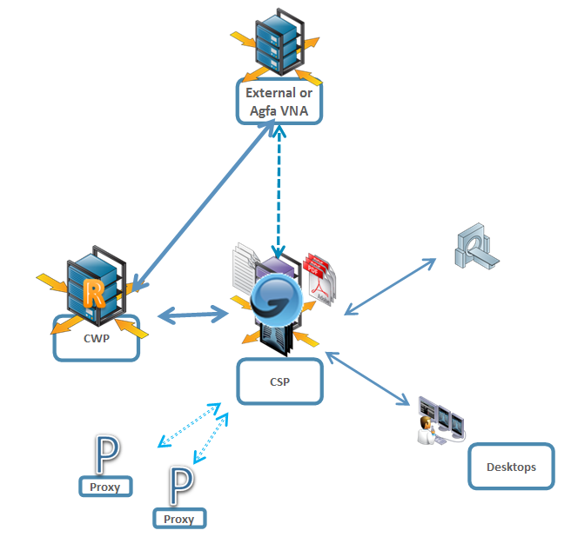

|  |
| --- |
|  |

### Scope

|  |  |
| --- | --- |
| Enterprise Imaging Installation | |
| Enterprise Imaging to be installed | YES |
| Enterprise Imaging License Volume | Core |
| Single or Dual Datacenter Configuration | Dual |
| Hardware to be provided by | Customer |
| Clinical Systems | One (1); GE Centricity RIS |
| Message Sources | One (1); Site Interface Engine |
| Patient ID Domains | One (1); EMPI (Agfa Provided) |
| Interface Engines | One (1); CorePoint |
| Enterprise Imaging PS | Five (5) Days |

*Note - Data migration is not in scope of this service, see data migration section.

### Enterprise Imaging Components

### Backend components

| **Desktop** | **Description** |
| --- | --- |
| Core Server Platform (CSP) | The CSP is essentially the application server. It hosts workflows, connectivity, manages image caches and serves connections to the desktop and mobile applications.  Depending on the production volume, one or more CSP servers are required. Consult the Platform Definition Documents for scaling guidelines.  The CSP is windows based. |
| Database server | The database server hosts an Oracle database which stores all clinical information as well system configuration settings.  Oracle Data Guard and Oracle Database Appliance are both supported.  The database server is standard available on windows, but is compatible with linux. |
| Proxy Server | The Proxy Server is intended when modalities, desktop and mobile applications are located in a remote site. The Server optimizes connection to the CSP for high-latency connections typical for telco.  The Proxy Server is windows based. |

### Desktop and Mobile Applications

| **Application** | **Description** |
| --- | --- |
| Diagnostic Desktop | View patient and image information, and perform diagnostics to complete reports and studies |
|  |  |
| Medical Secretary Desktop | The Medical Secretary Desktop supports the two main task types – patient and order – typically performed by a medical secretary or receptionist in a medical imaging department.  In addition transcriptionist work is done in this desktop as well. |
| Technologist Desktop | The technologist functionality includes acquisition of studies, management of modality worklists and QC procedures such as merging and splitting studies. |
| Administrator Desktop | Set up, manage and maintain all client desktops and server configurations |
| Clinician Desktop | View patient and image information. |
| XERO viewer | XERO® is the solution universal web viewer. XERO® can be deployed to support LAN and secure WAN and internet access. |
|  |  |
| Report sign-off | This application allows you to perform sign-off tasks from a mobile device (providing you have permission) and, optionally, send a report for correction. |
| Teaching files | The teaching file viewer connects to the (optional) teaching file archive to display and manage teaching files. Note that creation of teaching files can be completed from the Diagnostic, Acquisition and Clinician desktops, provided permissions are granted. |

### Detailed Architecture

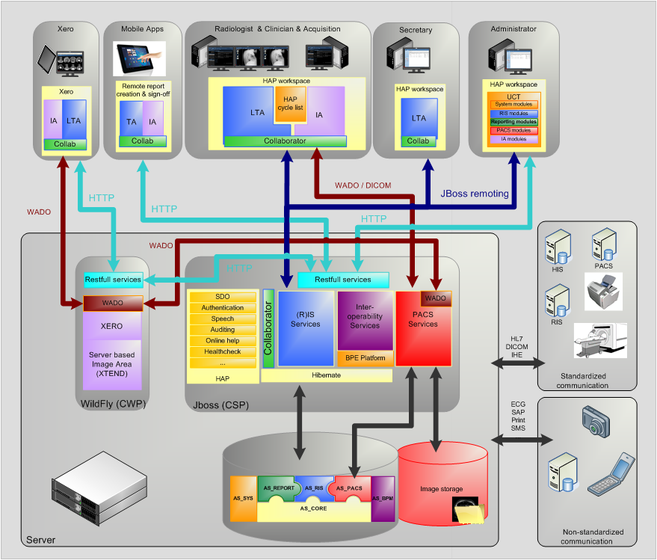

## System Scaling

The type, amount and configuration of Enterprise Imaging hardware, software, licenses and services have been based on a specified number of studies per year.

|  |
| --- |
| **.** Yearly production volume is approximately: 200,000 studies. |

## System Language

The configuration of the system, as well as any licenses will be in the following language.

|  |
| --- |
| System language: English. |

## References

|  |  |  |  |  |
| --- | --- | --- | --- | --- |
| **Document** | **Rev.** | **Owner** | **Status** | **Date** |
| Solution Architecture Workbook | 1.0 | Bill Keller | Reviewed with and sent to Methodist 1/25  Livelink***** | 1/14/2016 |
| Agfa VPN checklist with requirements and optional ports |  | Charlie Tripodi |  | Current version as of Feb 3, 2016 |

|  |  |
| --- | --- |
| Document | Location |
| AGFA HL7 Conformance Statements | http://www.agfahealthcare.com/global/en/main/products_services/product-info/interoperability/hl7/index.jsp |
| AGFA DICOM Conformance Statements | http://www.agfahealthcare.com/global/en/main/products_services/product-info/interoperability/dicom/index.jsp |
| AGFA IHE Conformance Statements | http://www.agfahealthcare.com/global/en/main/products_services/product-info/interoperability/ihe/index.jsp |

## Solution Deployment and Data Flow Diagrams

This project only applies to the MHS portion of the project. STRG project is not included in this SOW. Representative storage configuration shown. Actual storage optimization plan will be developed as part of the deployment plan.

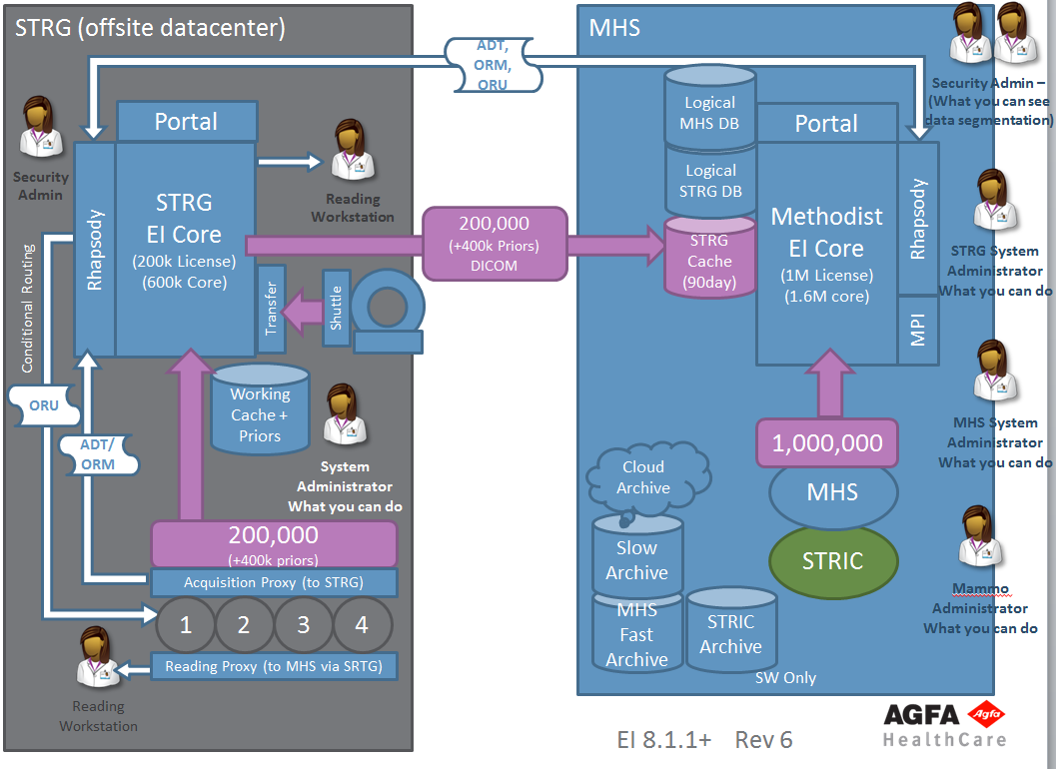

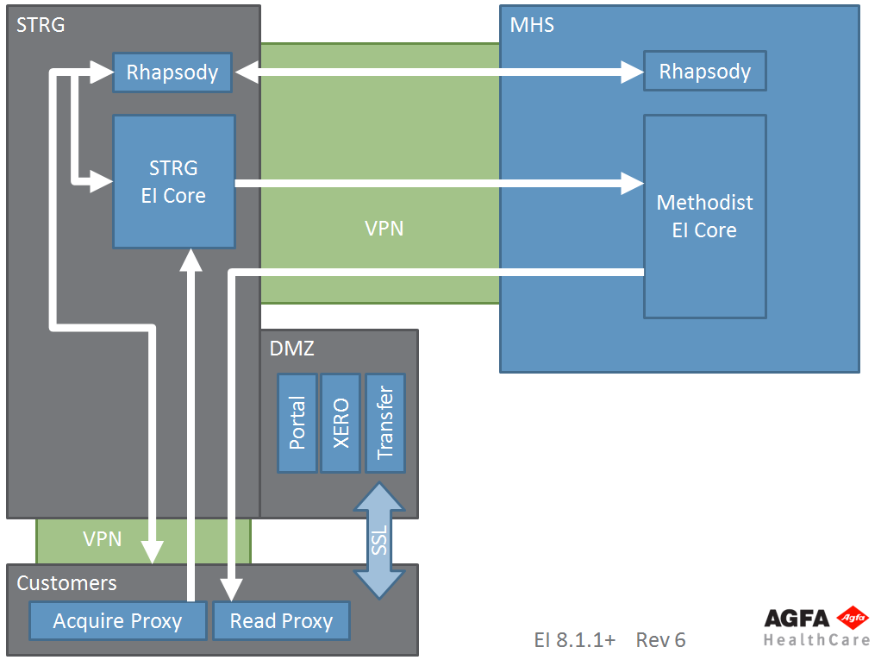

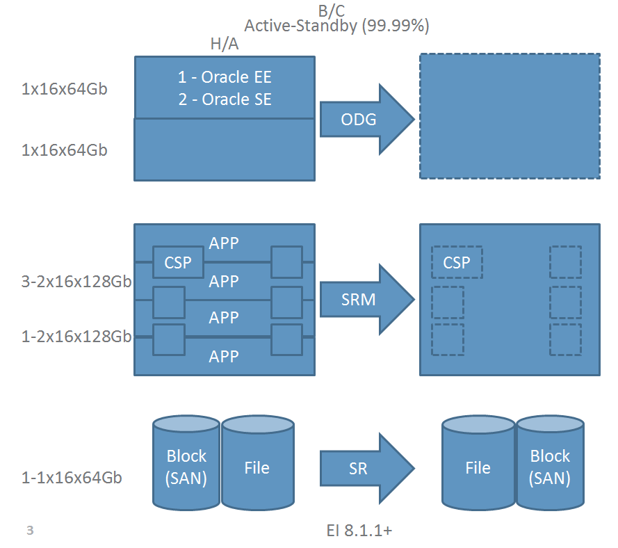

STRG Custom Workflows:

As shown in the diagram, radiologists will have access to the studies at outlying sites via a path through the Methodist system. This workflow uses a "READ" proxy located at each outlying hospital/center. This configuration allows radiologists to read studies that were captured at Methodist from a workstation at the outlying facility. There are services to deploy up to 4 Read proxies included in the proposal.

There has also been discussion about an "ACQUISITION" proxy at each site. Proxies provide compression in order to forward studies to the reading core. The workflow is anticipated to be just a forward rule to the STRG core. Acquisition proxies can replace the READ proxy if preferable.

Note that the Methodist infrastructure is not included in this scope of work, but is shown so that the design does not include any barriers that would prevent the overall planned vision.

Hardware shown above is a suggestion. Please refer to the Solution Architecture Workbook or the STRG VM + Storage Requirements document for detailed hardware and storage requirements.

## Network Specifications

The specifics of the network are dependent on the required services and customer size. In general, management, production and storage network VLANs are required for the back end servers in addition to the hospital production network and optional DMZ. Customers are responsible for all network components and configuration, unless consulting and/or implementation services are contracted with Agfa professional services.

Network details still need to be discussed because of the large number of studies that come into the system, but are not stored locally. This scenario does not align with the standard Agfa guidelines, and as a result we will do some research and discuss options that may be available in the STRG data center.

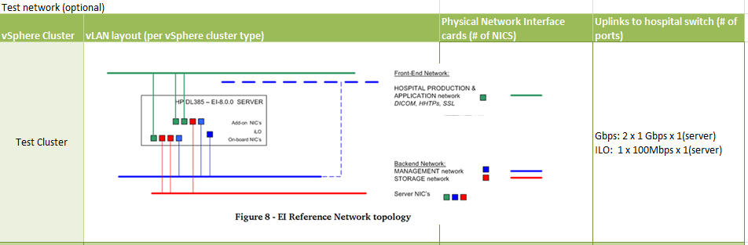

|  |  |
| --- | --- |
| warning | **REMARK**  A secure connection between the Customer and AGFA HealthCare is required.  The SRSS (Secure Remote Service System) is designed to support Agfa equipment in the customer’s premises. To do so, Agfa must have a connection to the customer and needs the possibility to address all devices on the customer network. |

## Licenses and Auxiliary Equipment

This project will install, activate and/or register the following licenses (please refer to the quote):

* MS Windows OS licenses – customer provided
* Oracle license – Note that the number of licenses provided was based on the Agfa Solution workbook and server layout as identified on the quote. Customer is responsible for additional licenses if needed for a different design.
* JBOSS licenses – Note that the number of licenses provided was based on the Agfa Solution workbook and server layout as identified on the quote. Customer is responsible for additional licenses if needed for a different design.
* Enterprise Imaging licenses
* Nuance SpeechMagic
  + Speech software
  + Speech recognition vocabulary manager
* Speechmikes – the final speechmikes are to be determined

## Connection to DICOM Modalities

Following an integration analysis, all configurations are (for customer) performed to:

* Make the modality accessible by Enterprise Imaging
* Integrate the transmitted images in the Enterprise Imaging workflows
* Configure modality worklist, if applicable

Validation activities will be performed, documented and reported to the Customer. Please note that installation of modalities is not included.

Customer responsibilities are:

* All modalities or PACS Systems that need to connect to Enterprise Imaging must comply with the required DICOM SOP classes (Enterprise Imaging DICOM Conformance statement can be provided upon request).
* Third party support or other costs that may be required by the PACS/Modality/Entity vendors are the responsibility of Customer
* Schedule modality and external system suppliers to cooperate in integration services.

## Task-Driven Workflows

Enterprise Imaging provides a set of best practice workflows and task assignment configurations.

Following a prior workflow analysis, modifications can be made to more precisely meet the Customer workflow needs.

This workflow scenario will be investigated to determine what can be automated -

In regard to Research workflows -- It has been requested that all studies for a certain Issuer will go into an “assigner” pool. The resource(s) that have access to these studies once they have been separated from other new studies, and will then assign the studies to the appropriate radiologist. If possible, when same patient comes back in, their study should go back to the same radiologist. Validation activities will be performed, documented and reported to the Customer

## Training

Key User: It is essential that any key-user (PACS administrators) is well trained in Enterprise Imaging features which are part if his/her role. This course is focused on the configuration, maintenance, and support of the Enterprise Imaging system with primary focus on the client application and clinical workflow configuration. In addition to the topics in end-user training, each student will gain a thorough understanding in:

* Quality Control activities to split, merge, .etc… studies
* Manage demographic lay-outs
* Manage body-parts
* Routing rules
* Basic troubleshooting

End User: The objective of this training is to instruct end-users how to use the Enterprise Imaging system to perform their daily work.

AGFA HealthCare's Application Specialists will deliver training based upon the schedule that has been developed by Customer in coordination with the Project Manager and availability of AGFA HealthCare Resources. This schedule should take into consideration the number of training days purchased that includes preliminary on-site configurations and the post follow up visit.

Radiologists receive a 2-hour personal training. Clinicians, Technologists, Medical Secretaries and Transcriptionists are trained in 2-hour group session specific for their role.

**Note:** Training days are based on 2 super users, 17 radiologists and a total of 12 resources who will use EI reporting. Depending on the volume of staff requiring training, additional training may need to be scheduled after the go-live.

Admin Training: This course is focused on the configuration, maintenance, and support of the Enterprise Imaging system with primary focus on the technical infrastructure and day-to-day maintenance:

* User management
* Configuring hospital organization changes in facilities, departments, etc
* Managing licenses
* Performing and scheduling backups
* Basic troubleshooting

The ideal timing for all Enterprise Imaging System Administrator & Key User trainings is no earlier than 8 weeks prior to a new install.

## Customer Managed Infrastructure Solution

Agfa HealthCare (“Agfa”) typically sells the Enterprise Medical Imaging solution in a “turnkey” model consisting of hardware, software and professional services, supported under a service maintenance agreement. In this model, Agfa has clear and broad responsibility for the availability, capacity and response times of the solution including the underlying, dedicated storage solution that Agfa sells to the customer.

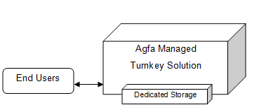

In an alternative customer-managed hardware model, the Agfa-managed solution is critically reliant on the availability, capacity and performance of the customer-managed equipment, which could include storage, servers or VMWare solution. Any issues with the storage solution’s availability, capacity or performance will negatively impact the users of the Agfa solution. Agfa, no longer responsible for the complete solution, will be dependent on the customer’s IT resources (and the customer’s hardware and storage vendor or vendors) to identify, troubleshoot and rectify any issues with the hardware solution.

The customer managed storage model increases the complexity of the overall solution as well as the number of parties responsible for various components of the solution. This will often result in additional time and expense to identify, troubleshoot and correct issues, which can be a source of end-user dissatisfaction. Also, there is the potential for confusion, lack of clear accountability or responsibility and even finger-pointing when Agfa, the customer, and the server or storage vendor each believe that their part of the solution is working properly, but when the combined solution is not meeting the expectations of the end users.

Nevertheless, Agfa understands that some of its customers have a desire or requirement to manage their own servers, storage, and virtual environments. There is also a desire to share the VMWare and storage infrastructures between Agfa and various non-Agfa applications. To protect the interests of both Agfa and the customer (including executives, end users and storage IT staff), Agfa has developed this Customer Managed Hardware Agreement.

The fundamental purpose of this agreement is to clearly establish mutual expectations as well as the roles and responsibilities of Agfa and a customer of Agfa’s solution(s), when used with a dependency on a customer-managed platform.

## Customer Managed Storage

### High Level Enterprise Imaging + Storage Diagram

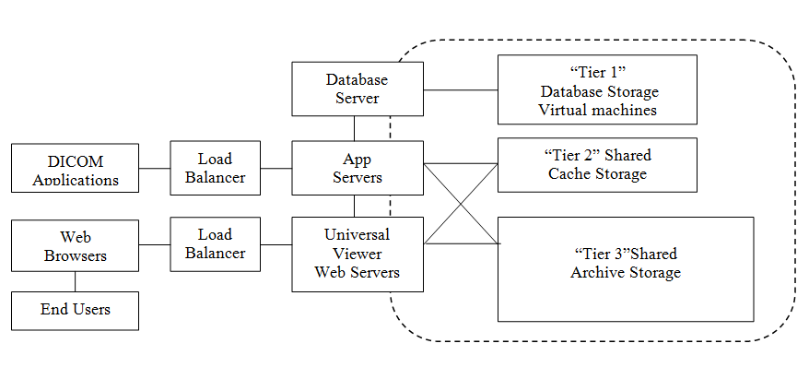

### Customer Managed Storage will be used for

Enterprise Imaging

* Database
* Cache
* Archive(s)

## Agfa Roles and Responsibilities for a Customer Managed Storage Solution

* **Change Control**
  + Agfa will communicate to the customer regarding all planned (or unplanned) downtimes, as well as anticipated, suspected or detected issues regarding the Agfa EI solution and the availability, capacity or performance of the underlying customer-managed storage solution.
* **Storage Requirements Specification**
  + Agfa will publish and maintain a Storage Requirements Specification document. Any future changes to these requirements shall be clearly communicated and every reasonable effort will be made to maintain back-compatibility with existing storage devices and data.
  + Agfa shall maintain application conformance with the Storage Requirements Specification.

## Ongoing storage integration services added into the service maintenance agreement (SMA)

For Enterprise Imaging CSP –

* Includes up to 8 hours of collaborative storage troubleshooting & resolution and
* Includes 1 of the following
* Consulting on one “Capacity Expansion” service / year
* Consulting and testing architecture improvements associated with an Enterprise Imaging software upgrade
* One “Connectivity and Performance Re-assessment” health check service per year when requested by the customer

## Customer’s Roles and Responsibilities for a Customer Managed Storage Solution

* **EI Storage Requirements Specification Conformance**
  + Customer will maintain storage solution conformance with the Agfa-published Storage Requirements Specification and customer specific Solution Architecture Workbook
  + Customer will manage the storage solution so as to maintain the directory layout and file system consistency and integrity of all Enterprise Imaging application-created directories and files
  + Customer is responsible for providing all storage connections between Agfa servers and storage.
* **Purchase of Customer Managed Storage Professional Services**
  + All storage solutions used in conjunction with Agfa’s solutions must pass the connectivity and baseline performance assessments (Storage ATP) in order for Agfa to provide warranty support for the Agfa solution.
  + On-going professional services in the form of a support agreement must be part of the maintenance agreement (SMA) in order to continue maintenance support on the Agfa solution.
  + Additional fees that result from the storage vendor as a result of integration test results are the responsibility of the Customer.
* **Single Point of Contact (SPOC)**
  + Customer will provide Agfa with a single point of contact (SPOC) for the customer-managed storage solution. This shall be an actual employee of the customer who is responsible for the storage solution, and not a storage vendor or IT outsourced resource.
  + In general, Agfa will not be working directly with the customer’s storage vendor, except when performing “Collaborative Storage Troubleshooting and Resolution,” as this may gradually undermine the clear responsibility that the customer has for the customer-managed storage solution.
* **Availability** 
  + Customer is responsible for the availability of the storage solution. When the storage solution is not available, the Agfa solution will also not be unavailable, and the end users will be denied service. Such time shall not be counted against any Agfa service level agreement with the customer.
* **Capacity Monitoring and Management**
  + Customer is responsible for monitoring the overall capacity and utilization of the storage solution, including database, online cache and archive storage.
  + Customer is responsible for acquiring, provisioning (expanding) and for change management, including requesting Agfa Professional Services for application re-configuration to take advantage of increased storage pools.
  + If the database, online cache or nearline archive runs out of storage, the application will be unable to function as expected and data loss may result.
* **Storage Subsystem Performance / Response Times**
  + Customer is responsible for the performance / response times of the storage subsystem at all times, including under load during peak utilization times, during data migrations, at all capacity and storage utilization levels, during recovery times (e.g., RAID disk rebuild, during post-loss data restoration, etc.).
  + Customer agrees that the Agfa application response times are strongly influenced by, and can never be better than the underling storage solution’s response times.
* **Storage Monitoring, Break/Fix, Vendor Service, Versions and Maintenance Agreement**
  + Customer is responsible for monitoring the storage solution for thresholds and faults and for coordinating break/fix activities with the storage vendor.
  + Customer is responsible for maintaining the storage solution under a vendor-provided Service and Maintenance Agreement.
  + Customer is responsible for maintaining the storage solution on vendor-supported and preferably vendor-recommended Software, Firmware and Hardware versions or revisions.
* **Change Control**
  + Customer will communicate in advance all storage solution (and therefore Agfa application) planned downtimes to Agfa Support and to the end users of the Agfa solution.
  + Agfa also recommends that the customer communicates in advance:
    - All planned storage subsystem configuration changes, even if no downtime is expected, because these events may cause changes in storage solution availability or response times. This includes capacity expansions, versioning, performance tuning, fault correction, etc.
    - Any reasonably anticipated, suspected or detected issues regarding the customer-managed storage solution.
  + Customer will communicate in a timely manner to all storage solution unplanned downtimes or degraded performance events to the customer’s end users and Agfa Support.
* **Storage Hardware Refresh & Data Migration**
  + As storage hardware approaches End of Service Life (EOSL), customer will be responsible for activities relating to storage hardware refresh and for the migration of database, online cache and nearline archival storage from the EOSL storage solution to the replacement storage solution.
  + Change control and joint planning will be required; and application reconfiguration professional services may be required.
* **Data Protection: Backup and/or Disaster Recovery**
  + Customer is responsible for data backup and disaster recovery of the storage solution to the extent that this is not already handled in Agfa’s architecture (such as an application-replicated solution with two distinct Enterprise Imaging instances with two distinct copies of the data located in two geographically distributed data centers).

## Agfa Roles and Responsibilities for Customer Managed VMWare environments

* **Resource requirements definition** 
  + Agfa will publish and maintain a list of applications that have been validated on VMWare.
  + Agfa will recommend the number of virtual machines of each application based on the customer’s imaging volume.
  + The resource requirements associated with each virtual machine will be published.
  + Agfa will provide guidelines on preferred storage connections between ESX servers and virtual machine storage.
* **Virtual infrastructure Design Guidelines**
  + Agfa will provide guidelines for virtual management settings to provide a satisfactory radiologist experience
* **Software installation and testing – Required for all customer managed environments**
  + Agfa will load software and licenses per the customer’s order
  + Agfa will load operating systems
  + Agfa service will complete the software Acceptance Test procedures (ATP)
  + Agfa will complete the VMWare environment acceptance test procedure
* **Proactive monitoring of Agfa software (GRIP) is provided to actively monitor the system for issues**

## Customer’s Roles and Responsibilities for Customer Managed VMWare Environments

* **Adherence to Design Guidelines and Resource Requirements** 
  + Customer will create virtual machines that meet the Agfa guidelines in preparation for Agfa to load software
* **Providing ESX licenses, servers and storage that meet or exceed the minimum requirements to run Agfa applications**
* **Providing the Operating System licenses needed by each Agfa application, unless included in the Agfa quote**
* **Internet access to Agfa’s ftp software location**

This may require that IT security personnel assist with allowing access to the Agfa ftp site in order for Agfa to download software updates or new software versions as part of an installation. Broadband internet speeds (min 10Mbps) must be available. If this access cannot be provided and a software download is needed, Agfa’s field service engineer will deliver the software to the site at the current labor and travel rates.

* **Providing permanent remote access to the Agfa virtual servers for installation, testing and maintenance support.**
* **Providing temporary guest access or WebEx access to virtual center settings for the cluster with Agfa VMs to complete acceptance testing.**
* **Providing a user login/password for virtual center or telephone numbers for escalation to customer IT personnel to be used when support is needed on the system**
  + Agfa will provide a form that covers this information that will be stored in our remote support SNDB system to be used for support.
* **Participation in HA testing and acceptance testing**
  + The order in which servers are restarted is important – Agfa can provide this information
* **Operating system patching and anti-virus protection per the Agfa recommended policies**
* **Backups**
  + Backups of the virtual machines are only needed after installation and before and after software updates
  + Backups of databases, voice files, etc to an enterprise location outside of the virtual machine is the customer’s responsibility

## Business Continuity

Agfa will assist Customer to translate the technical design into a test plan and shared procedures that will be kept by both organizations in the event of an outage of either a portion or all of the hardware and software and infrastructure of an Enterprise Imaging solution.

The outage scenarios will generally fall into 2 general categories.

Level 1 – High Availability = Redundant servers. The impact of an outage of any individual server should be able to be minimized by having backup servers to take its place. Load balancing and VMWare technologies are typically used to automate failover as much as possible.

Level 2 – Business Continuity = Datacenter outage, requiring failover to the disaster recovery data center

Testing and implementation of failover procedures assume that trained and knowledgeable resources are available and have access to site specific information including network and server infrastructure information.

**Deliverables**

Following are the Business Continuity deliverables from Agfa Professional Services

* **Failover Standard Operating Procedures**

For each outage scenario, we would develop a failover procedure, a recovery procedure and checklists that can be used after the failover or failback to confirm that the system is operational.

* **Failover test plans, results and pass/fail acceptance**

Testing of the procedures is conducted, preferably before the Enterprise Imaging system goes live in production. This confirms that the design works as planned, communication procedures within both Agfa and UCSF are in place, and any “gotchas” are identified before there is an actual event that requires using the business continuance

The number of days of professional services that are planned for the testing and documentation above is reflected on the quotation.

Follow-up professional services, to routinely test failover scenarios is outside of this scope of work, but can be built into the SMA (Service Maintenance Agreement)

### Oracle Data Guard Implementation

Oracle Data Guard is the management software infrastructure that creates, maintains, and monitors one or more standby databases to provide disaster recovery resiliency for the Enterprise Imaging database .

A secondary Oracle Server is installed and configured to act as a live-standby that can provide automated database replication and fast database failover facilities in the event of a problem with the primary Oracle Server (normally on the order of seconds to 1-2 minutes once the failover decision is made). Backup systems can be placed on a local network or wide-area network. Redundant storage for the database and redundant archive storage are elements of the solution.

**Infrastructure Pre-requisites**

The following prerequisites must be met in order to ensure a successful installation of Oracle Data Guard.

* The database must use Oracle 11g Enterprise Edition or above.  
  The customer is responsible for providing server and database resources and storage hardware
* The server hardware used for the secondary server must be compatible in specifications and performance with the primary server. Also, for optimal disaster recovery and business continuity, each database server requires its own independent storage solution of comparable capacities for the database – do not use a single storage device for both servers as then this storage device is a single point of failure.
* The bandwidth between the primary and secondary sites must meet a minimum specification of 100Mb/s. 1 Gbps is preferred
* The file structure and storage capacity must be identical on the primary and secondary systems.

Note: The total downtime of the primary database to implement and test this solution is can be as much as 10-12 hours. It is highly recommended to implement this solution prior to production go-live.

**Service Approach**

* Implementation of the Data Guard configuration on the disaster recovery server
* Implementation of the Data Guard configuration on the primary production database server
* If a pre-production database has been configured as part of HL7 testing or as part of a study migration, a copy of that database is made. This will require downtime on the pre-production system.
* Configure Oracle communication on the servers that are communicating with the production database
* Testing of the failover / switchover process

**Customer Responsibilities**

1. Customer is responsible for all network / firewall configuration / topology / bandwidth requirements between data centers and servers.
2. Customer should participate in switchover testing and acceptance

**Deliverables**

* Technical Project plan steps and Work breakdown structure for Data Guard implementation
* Data Guard replication setup from Server-1 to Server-2
* Acceptance test

### Core Platform Service Approach

*Hardware Installation*

* Enterprise Imaging Pre-Install and Site Readiness
* Enterprise Imaging Remote Connectivity Configuration
* Enterprise Imaging Hardware Readiness (SATP-1)
* Enterprise Imaging Network Configuration
* Enterprise Imaging Core Software Installation
* Enterprise Imaging Acceptance

*Core System Configuration*

* Enterprise Imaging Business Analysis & Strategy Presentation
* Enterprise Imaging System Build (Master Files)
* Enterprise Imaging Connectivity Configuration
* Enterprise Imaging Capture Configuration (SATP-2)

*Training*

* Enterprise Imaging Administrator Training
* Enterprise Imaging End User Training (use case specific)

*Service Acceptance*

* Enterprise Imaging Testing
* Enterprise Imaging Acceptance (CATP)
* Enterprise Imaging Transition to Agfa Service

Enterprise Imaging Business Analysis

Agfa will review the Business Analysis and attempt to adapt the application to meet the needs of the site within the Scope of the project. The workflow that is detailed, discussed, and agreed upon in the Business Analysis project milestone will be the main focus of the configuration and system build. Agfa will make minor modifications to the setup / configuration up until the go/no-go project milestone to meet the needs of the site, or help provide a work-around if the workflow is limited by other factors.

Enterprise Imaging Administrator Training

For a “train-the-trainer” training, Agfa will teach a limited number of trainers (Key Users or Super Users) in the subject matter of the application. Agfa will also guide these trainers how to teach the end users of the application. The Key users or Super users are then responsible for teaching the training to all other users of the system. Agfa will not provide further assistance (e.g. training material …) for the training sessions given by the Super Users to the trainees. Agfa will not train Customer in methodology to perform training. For all training sessions, Agfa will provide training on the application and basic setup only.

### Admission, Discharge, and Transfers (XADT)

The patient is registered in the EMR or HIS and the ADT is sent to Enterprise Imaging. The ADT will be forwarded on to the proper actors within the Enterprise Imaging solution. The patient arrives, and any updates are sent from the Meditech EMR to Enterprise Imaging. Patient demographic updates will be propagated to the Enterprise Imaging actors. If the patient is registered in Enterprise Imaging, and the images are acquired via Enterprise Imaging Capture, forwarded to Enterprise Imaging VNA, and the EPR message is sent to the EMR, then a manual merge may be required.

Agfa Enterprise Imaging Services involved: PM, Global TS, Applications

* EMR will send Enterprise Imaging an unsolicited ADT feed
* The EMPI MRN will be utilized for all patients.

### External Orders (XORD)

The patient is registered in the EMR or HIS and the ADT is sent to Enterprise Imaging. The clinician or ordering physician will place an order for the service line in the EMR. This ORM will be sent to Enterprise Imaging, forwarded to the Enterprise Imaging actors, processed, and filled. An alternate workflow could be that an SIU (scheduling SCH) message is sent from the enterprise scheduling system to Enterprise Imaging where it is converted to an ORM, processed, and filled. A last alternate workflow may be that an order is created and filled by an Image Management System (IMS) and is forwarded to Enterprise Imaging to be utilized for image verification.

Agfa Enterprise Imaging Services involved: PM, Global TS, Applications

* EMR will send Enterprise Imaging an unsolicited ADT feed
* The EMR will send an ORM to Enterprise Imaging to be filled.

**External Modality Image Acquisition (XMOD)**

The modality will start the acquisition protocol. The modality will query the Enterprise Imaging DMWL (or XPACS worklist), for the XORD or IORD that was placed for the procedure. The modality acquires the images and sends the images to Enterprise Imaging. The images are then auto-verified against the order and sent to Enterprise Imaging VNA for archive. The images can also be held in Enterprise Imaging where manual verification QC can be completed in Enterprise Imaging before the images are sent to Enterprise Imaging VNA for archive.

Agfa Enterprise Imaging Services involved: PM, Global TS, Applications

* Images are acquired at the modality utilizing DMWL from Enterprise Imaging (or XPACS), sent to Enterprise Imaging where either auto or manual verification takes place, and the images are sent to Enterprise Imaging VNA for archive.

**Exception Workflow (FIXV - Fixup Workflow)**

Department sends study and it is received by Enterprise Imaging VNA. An EPR message is sent to Connectivity Manager where it will search for the associated order (on MRN, accession, SIUID). If there is no match, the study will be routed to Enterprise Imaging for manual verification. The study can be fixed up within Enterprise Imaging.

Agfa Enterprise Imaging Services involved: PM, Global TS, Applications

* Images are sent to Enterprise Imaging, verification fails, and manual fixup process is required to archive images to Enterprise Imaging VNA.

**Image Quality Control (QCV - QC Workflow)**

Department sends study and it is received by Enterprise Imaging and it fails verification. This study will be sent to the Enterprise Imaging QC pipeline and can be modified with Enterprise Imaging. A study split, merge, etc can be completed and Enterprise Imaging will register, verify, and archive the new studies, as well as remove the old one from within Connectivity Manager.

Agfa Enterprise Imaging Services involved: PM, Global TS, Applications

* Images are sent to Enterprise Imaging, verification fails, and QC workflow is required for split, merge, etc. QC process is completed, studies are registered, verified, and archived to Enterprise Imaging VNA.

### Enterprise Imaging EMR Notification

Agfa Enterprise Imaging Services involved: PM and Global TS

Integration of Enterprise Imaging VNA with an Electronic Medical Record (EMR) system where Enterprise Imaging VNA provides an HL7 study availability notification message.

### Information Lifecycle Management (ILM)

Agfa Enterprise Imaging Services involved: PM and Global TS

Information Lifecycle Management (ILM) is an optional component of Enterprise Imaging VNA. Containing a software and database component, ILM will enable data retention policies in Enterprise Imaging VNA. There are server, database and client aspects of ILM.

### Expected Environment

| Enterprise Imaging Network and Server Requirements |
| --- |
| Hardware and Server requirements are specified in the “Enterprise Imaging Solution Platform Definition and Deployment Configurations” document. Customer provided hardware must meet or exceed Agfa HealthCare defined minimum specifications |

|  |  |  |
| --- | --- | --- |
| Enterprise Imaging Workstations | |  |
| Diagnostic Workstation Premium | Diagnostic review and reporting of standard radiology, cardiology and multi-modality nuclear medicine examinations. Can be used for Clinical Applications. | HP Z440 Workstation – “Premium Diagnostic 2015.1 “– Platform Design document. |
| Diagnostic Workstation Standard | Diagnostic review and reporting of standard radiology, cardiology and multi-modality nuclear medicine examinations. | HP Z440 Workstation – “Standard Diagnostic 2015.1 “– Platform Design document    HP Z230 Workstation – “Premium Clinical Tower 2015.1 “– Platform Design document –(Single Graphic card support)  HP Z230 Workstation – “Premium Clinical SFF 2015.1 “– Platform Design document –Low Height Single Graphic card only) |
| Clinical Workstation Premium | intended for non-diagnostic clinical review of examinations and QC operations, including technologist desktop | HP Z230 Workstation – “Premium Clinical Tower 2015.1 “– Platform Design document –Single Graphic card support)  HP Z230 Workstation – “Premium Clinical SFF 2015.1 “– Platform Design document –Low Height Single Graphic card only) |
| Clinical Workstation Standard | intended for non-diagnostic clinical review. | HP Z230 Workstation – “Standard Clinical Tower 2015.1 “– Platform Design document –Single Graphic card support)  HP Z230 Workstation - "Standard Clinical SFF 2015.1 "- Platform Design document - (Low Height Single Graphic card only)   * HP Elite Desktop 705 G1 AIO – “Premium Clinical AIO 2015.1 “– Platform Design document – (No add Graphic card support) * HP Elite Desktop 705 G1 AIO – “Premium Clinical Micro 2015.1 “– Platform Design document –(No add Graphic card support) |
| General Purpose Desktop | for Administrative purposes, RIS Management, Web 2.0 applications such as EI VIEW Web viewer, Sign-off list | HP Elite Desktop 705 G1 AIO – “Premium Clinical AIO 2015.1 “– Platform Design document – (No add Graphic card support)  HP Elite Desktop 705 G1 AIO – “Premium Clinical Micro 2015.1 “– Platform Design document –(No add Graphic card support) |

* Readiness Assessment has been completed.
* Enterprise Interface Engine is configurable to send to send necessary HL7 feeds to Enterprise Imaging Connectivity Servers
* DNS (Domain Name System) is utilized on the network

### Agfa Responsibilities

Provide resources to execute the Service Approach

### Customer Responsibilities

* Provide Customer and/or Customer Vendor resources to assist Agfa in the Service Approach.
* Customer shall be responsible for providing the supporting infrastructure such as, but not limited to, equipment ready server & diagnostic rooms (air conditioning, lighting, etc.).
* Prepare Enterprise Imaging CWP server rack environment including cabling and UPS per the Enterprise Imaging XERO Pre-Installation and Site Readiness Report.
* Rack Enterprise Imaging CWP server(s) and connect to network.
* Provide redundant power circuits to Enterprise Imaging CWP Servers.
* Ensure all ports identified in the Enterprise Imaging XERO Pre-Installation and Site Readiness Report are accessible and open for remote access.
* Configuration of inbound and outbound interfaces from Clinical System and Interface Engine to Enterprise Imaging interface specifications.
* Validation of Enterprise Imaging Master Files.
* Validation of order placer/filler and clinical capture workflows.

### Deliverables

*Enterprise Imaging* Clinical Acceptance Test Plan

### Reference Documentation

|  |  |  |
| --- | --- | --- |
| Documentation | Format | Number of copies |
| Installation guide | Electronic, pdf | 1 |
| Migration guide | Electronic, pdf | 1 |
| Hardware-software specification | Electronic, pdf | 1 |
| Connectivity compliance claims | Electronic, pdf | 1 |
| Getting started manual (end user documentation) and workflow guides | Electronic, pdf & html | Available from a shared location |
| Application knowledge base (key user/super user documentation) | Electronic, html | Installed on key-user workstations or available from a shared location |
| Release notes | Electronic, pdf | 1 |
| Configuration tutorial | Electronic, pdf & html | Installed on key-user workstations or available from a shared location |
| Connectivity documentation | Electronic, html | Installed on key-user workstations or available from a shared location |

Service Completion Acknowledgement:  
The customer Project Manager will be requested to acknowledge the completion of the Enterprise Imaging CSP Installation Service by signature of the Enterprise Imaging Clinical Acceptance Test Plan.

### Enterprise Imaging CWP (XERO) Viewer Core Installation

### Purpose

Enterprise Imaging XERO Viewer Core Installation provides initial installation and configuration of the Enterprise Imaging core web platform (CWP) servers. Core installation consists of: Platform configuration, connectivity, storage configuration, license installation, security certificate installation, availability configuration, and testing.

### Scope

|  |  |
| --- | --- |
| Enterprise Imaging CWP (XERO) Core Installation | |
| Enterprise Imaging XERO to be installed | YES |
| Enterprise Imaging XERO License Volume | Core |
| Single or Dual Datacenter Configuration | Dual |
| Primary Enterprise Imaging XERO VNA Location | TBD |
| Secondary Enterprise Imaging XERO VNA Location | TBD |
| CWP (XERO) Integration into EMR | Yes: Meditech |

### User Authentication – CSP Integration

Integration with the CSP server will enable secure user authentication without requiring user credentials to be passed. The use of an existing customer database/web service authentication role and group values will eliminate the need for a standalone Enterprise Imaging XERO Viewer authentication method.

Agfa Enterprise Imaging Services involved: PM, Global TS, Applications

### User Authentication – LDAP

The LDAP (Lightweight Directory Access Protocol) authentication service provides direct-access user authentication to Enterprise Imaging XERO Viewer. Users accessing the Enterprise Imaging XERO Viewer server using LDAP authentication will be presented with a login dialog, there the user will enter their credentials. If the credentials are authenticated against the LDAP authentication server, the user will be granted access to view data images in Enterprise Imaging XERO Viewer. Additionally, the customer may request themes be mapped to associated LDAP user groups. These themes can control: data access, data filtering and presentation customizations.

Multiple LDAP integrations are supported. Typically the services needed for a single LDAP domain is 2 days and 1 day for each additional domain.

Agfa Enterprise Imaging Services involved: PM, Global TS, Applications

### Theme/Report Customization

The Theme/Report Customization service purpose is to identify, develop, and deploy custom Enterprise Imaging XERO Viewer user interface Themes and/or Report templates.

Customization can be applied to adapt the Enterprise Imaging XERO Viewer user interface to particular organizational or departmental needs. Customization can modify elements, such as authentication methods, colors, button icons, search columns, and label headers. Customization can also be applied to report templates to include custom formatting and/or custom letterhead universally or for select report sources.

Agfa Enterprise Imaging Services involved: PM, Global TS, Applications

### Image Manager Integration via DICOM Interface

Integration of Enterprise Imaging XERO Viewer with a single DICOM image manager via the DICOM Interface. The DICOM image manager must meet minimum DICOM connectivity and performance requirements as evidenced by passing the qualification tests of the Enterprise Imaging XERO Viewer Validator tool.

Agfa Enterprise Imaging Services involved: PM, Global TS, Applications

### Configuring ATNA Audit Logging

XERO Viewer can provide ATNA Audit Logging messages and send the audit messages to one of the image managers.

Agfa Enterprise Imaging Services involved: PM, Global TS, Applications

### Integration with Enterprise Imaging Transfer

XERO Viewer can be integrated with Enterprise Imaging Transfer service profile. In this profile, unreconciled studies can be viewed in Transfer prior to being manually forwarded to a DICOM destination. The determination needs to be made if Transfer is the default AE for study queries on XERO Viewer. In some cases, Transfer will not be the default AE (Enterprise Imaging Desktops may be the default AE for study queries).

Agfa Enterprise Imaging Services involved: PM, Global TS, Applications

### Integration with Enterprise Imaging XERO Exchange Suite (Consumer Portal - MphRx Physician/Patient Portal)

XERO Viewer can be integrated with Enterprise Imaging Consumer Portal as part of the XERO Exchange Suite. In this profile, a custom API exists between MphRx and XERO Viewer to upload images from the Consumer Portal to XERO in a manner similar to XERO Capture. These studies will be DICOM encapsulated, and forwarded from XERO Viewer to Enterprise Imaging for verification QC / Fix-up, or sent directly to a DICOM store. XERO Exchange Suite is an optional extension to XERO and is not included by default. Customers must purchase this in addition to the base XERO Viewer application. To enable it, the appropriate API, user role and theme must be configured.

Agfa Enterprise Imaging Services involved: PM, Global TS, Applications

### Enabling Extended Viewing with Enterprise Imaging (Xtend)

Extended viewing is a licensed feature that customer sites must purchase. These features, bring many of the advanced capabilities from the Enterprise Imaging Diagnostic Desktop Image area.

Agfa Enterprise Imaging Services involved: PM, Global TS, Applications

### Enabling XERO Viewer Chat feature

XERO Viewer 8.0.0 introduces a chat feature that allows users to interact and collaborate with each other. To enable chat functionality for XERO Viewer, create a theme and define the XMPP settings in it. XMPP is the TCP/IP protocol for real-time chat applications.

Agfa Enterprise Imaging Services involved: PM, Global TS, Applications

### Enabling Full Fidelity functionality

XERO Viewer can be optionally configured for full fidelity mode, which is intended for diagnostic use, review, and analysis of CR, DX, CT, MR, and US images and medical reports. XERO Viewer full fidelity is not intended to replace full workstations and should only be used when there is no access to a workstation. XERO Viewer full fidelity is not intended for the display of digital mammography images for diagnosis. A Full Fidelity license is required. The license does not enable Full Fidelity functionality by default; you must set the Full Fidelity mode in the theme.

Agfa Enterprise Imaging Services involved: PM, Global TS, Applications

### Service Approach

* Enterprise Imaging XERO Viewer Project Kick-off Meeting
* Enterprise Imaging XERO Viewer Readiness Assessment
* Enterprise Imaging XERO Viewer Pre-Install and Site Readiness
* Enterprise Imaging XERO Viewer Remote Connectivity Configuration
* Enterprise Imaging XERO Viewer Hardware Readiness
* Enterprise Imaging XERO Viewer Network Configuration
* Enterprise Imaging XERO Viewer Core Software Installation
* Enterprise Imaging XERO Viewer Security Certificate Installation
* Enterprise Imaging XERO Viewer Load Balancer Environment Testing (as applicable)
* Enterprise Imaging XERO Viewer Image/Data Testing
* Enterprise Imaging XERO Viewer Acceptance
* Enterprise Imaging XERO Viewer Transition to Agfa Service
* DNS (Domain Name System) is utilized on the network.
* Enterprise Imaging CWP servers will utilize SSL for secure HTTPS communication to the client.
* When Enterprise Imaging XERO Viewer is deployed with CITRIX:
  + CITRIX Content Redirection is recommended to launch Enterprise Imaging XERO on the local workstation.
  + If CITRIX Content Redirection is not used, Agfa cannot predict **or assure Enterprise Imaging XERO Viewer performance or image quality.**

| Enterprise Imaging CWP Server and Network Requirements |
| --- |
| Hardware and Server requirements are specified in the “Enterprise Imaging Solution Platform Definition and Deployment Configurations” document. Customer provided hardware must meet or exceed Agfa HealthCare defined minimum specifications |

| Enterprise Imaging XERO Client Requirements | |
| --- | --- |
| Client Minimum Network | Client Recommended Network |
| 1 Mbps bandwidth with less than 150 ms latency | Greater than 5 Mbps bandwidth with less than 150 ms latency |
| Client Operating System | Client Browser |
| Windows, MacOS, Linux | Typical HTML 3.0 browser (See current Enterprise Imaging XERO browser compatibility chart for tested browser clients) |

### Agfa Responsibilities

* Provide resources to execute the Service Approach

### Customer Responsibilities

* Provide Customer and/or Customer Vendor resources to assist Agfa in the Service Approach.
* Prepare Enterprise Imaging CWP server rack environment including cabling and UPS per the Enterprise Imaging XERO Viewer Pre-Installation and Site Readiness Report.
* Rack Enterprise Imaging CWP server(s) and connect to network.
* Provide redundant power circuits to Enterprise Imaging CWP Servers.
* Ensure all ports identified in the Enterprise Imaging XERO Viewer Pre-Installation and Site Readiness Report are accessible and open for remote access.
* For customer supplied load balancers, configure the load balancers according to site topology and Agfa recommendations.
* For Enterprise Imaging VNA Customer Managed Storage, configure storage to grant Enterprise Imaging CWP servers rights to mount the storage volumes.
* Provide SSL certificate to enable HTTPS communication: See Enterprise Imaging XERO Viewer CSR SSL Certificate document.

### Deliverables:

* Enterprise Imaging XERO Viewer Pre-Installation and Site Readiness Report
  + Delivered by Agfa Project Manager at project kick-off meeting
* Enterprise Imaging XERO Viewer Project Plan
  + Delivered by Agfa Project Manager post project kick-off meeting
* Enterprise Imaging XERO Viewer Hardware Acceptance Test Plan or Virtual Environment Service Acceptance Test Plan
  + Delivered by Agfa Project Manager post hardware or VM installation
* Enterprise Imaging XERO Viewer Clinical Acceptance Test Plan
  + Delivered by Agfa Project Management initiation of Acceptance Testing

***Reference Documentation*** *(as required)*

* Enterprise Imaging XERO Viewer Health Check Information
* Enterprise Imaging XERO Viewer Application Backup Information
* Enterprise Imaging XERO Viewer CSR SSL Certificate Information
* Enterprise Imaging XERO Viewer User Documentation (web page)

Service Completion Acknowledgement:  
The customer Project Manager will be requested to acknowledge the completion of the Enterprise Imaging XERO Viewer Core Installation Service by signature of the Enterprise Imaging XERO Viewer Clinical Acceptance Test Plan. Enterprise Imaging XERO Viewer cannot be placed into Clinical use until Enterprise Imaging XERO Viewer Clinical Acceptance Test Plan documentation is completed.

### Enterprise Imaging Connect (Rhapsody) Core Installation

### Purpose

The Connect core installation solution provides seamless connectivity between legacy and next-generation health systems. Connect will handle all HL7 connectivity (inbound and outbound interfaces) for the Enterprise Imaging solution.

### Scope

|  |  |
| --- | --- |
| Connect | |
| Max Devices Per Bulk Load | Up to Fifty (50) |
| Number of Inbound Feeds | CorePoint |
| Number of Outbound Feeds | CorePoint  ORU Outbound |
| Message Source(s) | CorePoint Interface Engine (HL7 ADT, ORM, ORU, SIU) |
| System | Virtualized (VMWare) |
| Patient Identity Feed | One (EMPI); Meditech / MHS |
| Patient ID Domains | One (EMPI or enterprise PID) |
| Testing Time | Four (4) hours per interface |

### Connections will be via the customer provided CorePoint integration engine.

### Service Approach:

* + - * + Connect HL7 Outbound Test
        + Enterprise CATP

**HL7 Outbound Testing**

The customer will support Agfa in the testing of HL7 message flow into the Enterprise Imaging solution, and HL7 outbound message flow from Connect to other 3rd party systems for a period of time identified in Scope.

### Agfa Responsibilities:

#### Execute Connect Service Approach as defined in this SOW section.

### Customer Responsibilities:

#### Develop and execute a testing plan

#### Ensure HL7 messages are routed to Connect

The customer Project Manager will be requested to acknowledge the completion of the Connect Departmental Deployment Service by signature of *Clinical Acceptance Test Plan*.

### Enterprise Imaging Exchange Suite (Transfer) for Foreign Studies Core Installation

### Purpose

The Transfer installation provides a simple, safe and efficient way to import DICOM objects to PACS server or data center (e.g. VNA). Transfer is able to replace the portable CD/DVD and other DICOM importers. Transfer enables secure electronic exchange of medical imaging information across a WAN among affiliated healthcare institutions while eliminating the need for film, CD/DVD, or VPN.

### Scope

|  |  |
| --- | --- |
| Enterprise Imaging Transfer Installation | |
| Transfer Installed | YES |
| Solution | One; Transfer Application Server in DMZ and Transfer DB on internal Network for metadata storage. |
| Studies | DICOM studies |
| Results / Questionnaires | Results are not in scope |
| System | Virtualized (VMWare) |
| Professional Services | Five (5) days |
| Testing | One (1) day per source instance |
| Additional PS | TBD; any custom PS included for custom integration |

* Transfer will be a staged, pre-configured VM and a configuration guide will be available to Agfa services providing details to configure Transfer.
* The Transfer client will be downloadable to authorized users on the web user interface.
* A demilitarized zone (DMZ) will need to be established – a physical or logical subnetwork that acts as an additional layer of security between the facility’s LAN and the internet.
* A web-based help guide will be available for the end user via the Transfer user interface.
* Deployment of the Transfer database is a separate step that needs to be done prior to deploying the Transfer server.
* By default, the database schema required by Transfer will be built into theEI database ISO installer, but a separate schema installer will be available for Transfer in the event it is deployed alone or with other products.
* The deployment of Transfer will include the deployment of GRIP Monitoring agent.
* There is a health check of installed Transfer clients within the facility and authorized users can monitor them on the Transfer Management page of the Transfer user interface.

### Physical Deployment View

Transfer will be deployed as a VM and share the same Oracle database instance with VNA. All these virtual machines will run on ESXi server(s), like the Figure 1 shown below.



Figure 1, VM Deployment of Transfer

When implemented with VNA, Transfer will use the same storage drive as VNA to get high speed disk I/O and storage disaster recovery when available.

### Service Approach:

* + - * + Transfer Installation and Configuration
        + Transfer Test
        + Transfer Acceptance

### Agfa Responsibilities:

Execute Transfer Service Approach as defined in this SOW section.

### Customer Responsibilities:

* Provide Customer and/or Customer Vendor resources to assist Agfa in the Service Approach.
* Customer shall be responsible for providing the supporting infrastructure such as, but not limited to, equipment ready server & diagnostic rooms (air conditioning, lighting, etc.).
* Rack Enterprise Imaging Server Hardware and connect to network.
* Provide redundant power circuits to Enterprise Imaging Servers.
* Firewall configuration.
* Validation of Transfer workflows.

The customer Project Manager will be requested to acknowledge the completion of the Transfer Departmental Deployment Service by signature of *Clinical Acceptance Test Plan*.

### Exchange Suite - Consumer Portal (MphRx)

### Purpose

The Enterprise Imaging Patient/Physician Upload Portal installation provides a simple, safe and efficient way to import DICOM and non-DICOM objects to the transfer solution, and subsequently the Enterprise Imaging Workflow services. Enterprise Imaging Patient/Physician upload portal is able to replace the portable CD/DVD and other DICOM importers, as well as replace existing legacy patient CD import products. The upload portal enables secure electronic exchange of medical imaging information across a WAN or on the internal network.

### Scope

|  |  |
| --- | --- |
| Enterprise Imaging Consumer Portal Installation | |
| Portal Installed | YES |
| Solution | One; custom API between MphRx and XERO to upload studies |
| Studies | DICOM and non-DICOM studies |
| Results / Questionnaires | Results are not in scope, and questionnaires may come in an additional phase. |
| System | Virtualized (VMWare) |
| Professional Services | Five (5) days |
| Testing | One (1) day per portal instance |
| Additional PS | TBD; any custom PS included for custom integration |

* Enterprise Imaging Patient and Physician upload will be a staged, pre-configured VM and a configuration guide will be available to Agfa services providing details to configure Enterprise Imaging patient and physician upload.
* Images are uploaded through an HTML5 upload interface where available, or through a JAVA based uploader where HTML5 is not available.
* A Demilitarized Zone (DMZ) will need to be established – a physical or logical subnetwork that acts as an additional layer of security between the facility’s LAN and the internet.
* A web-based help guide will be available within the user interface.
* Deployment of the Enterprise Imaging Transfer solution needs to be completed prior to the installation of the Patient/physician portal.
* A Web form creation and deployment interface will be provided to allow for customer created workflows for patient and physician upload across various use cases.

### Physical Deployment

Enterprise Imaging Patient and physician upload portal will be deployed as a VM. All these virtual machines will run on ESXi server(s).

### Service Approach:

* First level support will be maintained by on-site Agfa.
* Additional support will be co-ordinated through Agfa, but managed by MphRx team and delivered through MphRx.

### Agfa Responsibilities:

* Execute Enterprise Imaging Transfer Service Approach as defined in this SOW section.

### Customer Responsibilities:

* Provide Customer and/or Customer Vendor resources to assist Agfa in the Service Approach.
* Customer shall be responsible for providing the supporting infrastructure such as, but not limited to, equipment ready server & diagnostic rooms (air conditioning, lighting, etc.).
* Rack Enterprise Imaging Server Hardware (or create VM) and connect to network.
* Provide redundant power circuits to Enterprise Imaging Servers.
* Validation of Enterprise Imaging Portal and Patient/Physician workflow.

The customer Project Manager will be requested to acknowledge the completion of the Consumer Portal Departmental Deployment Service by signature of *Clinical Acceptance Test Plan*.

### Enterprise Imaging Business Intelligence (BI) Installation

### Purpose

Enterprise Imaging BI is a data warehouse and database reporting solution. The solution moves and transforms data from Enterprise Imaging VNA and Enterprise Imaging databases to a Data Warehouse database. On top of this DW database a simplified business model view is created that allows customers to easily create and view (BI) reports through a reporting tool (OBI).

Following use cases apply to the Enterprise Imaging BI end user:

* As an Enterprise Imaging BI author I want to be able to create and/or edit reports and/or graphs on data available in my Enterprise Imaging Server and/or Enterprise Imaging VNA databases.
* As an Enterprise Imaging BI consumer I want to be able to run reports and/or graphs on data available in my Enterprise Imaging Server and/or Enterprise Imaging VNA databases.

Enterprise Imaging comes with a Standard BI offering – This includes:

* 5 Author licenses – allows different departments to view and create their own reports.
* BI Implementation – Service Installation is free, project management and customer training have fees attached. Additional hardware resource requirements are the responsibility of the customer.
* Set of Management Reports – 14 operational metrics reports & 11 dashboards

Add on offerings are available for purchase:

* Additional available reports – Patient List, Procedural, VNA volume
* Additional user licenses – Authors and consumers
* Professional Services -- Customized reports, system configurations, additional training, and workshops

Management Reports is installed on a virtual machine hosted by a server running **VMware ESXi 5.x** Server or on the customer’s existing VMware infrastructure. The virtual machine uses **Windows 2012 R2** (64 bit only) Server OS. The solution consists of the Oracle 11g **Analytics Engine** services, the data **Extraction, Transformation and Loading** (ETL) services and the Oracle 11g **Data Warehouse** instance.

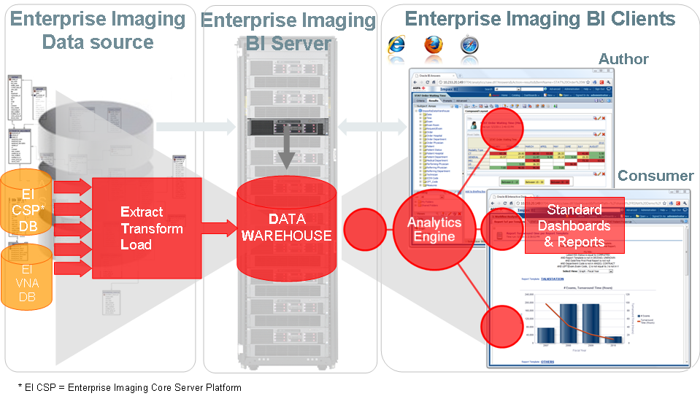

**Scope**

|  |  |
| --- | --- |
| Enterprise Imaging Business Intelligence Installation | |
| Enterprise Imaging Business Intelligence to be installed | YES |
| BI Author and Consumer Services Configured | YES, Author and Consumer |
| Enterprise Imaging BI Licenses | Five (5) |
| ETL Services on IMPAX, CSP, and VNA | YES, CSP |
| Additional Reports Required | TBD |
| Professional Services | Five (5) Days |
| Additional PS | TBD; any custom PS included for custom integration |

### Service Approach:

* + - * + Enterprise Imaging Business Intelligence Installation and Configuration
        + Enterprise Imaging Business Intelligence Test
        + Enterprise Imaging Business Intelligence Acceptance

### Agfa Responsibilities:

* Execute Enterprise Imaging Business Intelligence Service Approach as defined in this SOW section.

### Customer Responsibilities:

* Provide Customer and/or Customer Vendor resources to assist Agfa in the Service Approach.
* Customer shall be responsible for providing the supporting infrastructure such as, but not limited to, equipment ready server & diagnostic rooms (air conditioning, lighting, etc.).
* Rack Enterprise Imaging Server Hardware and connect to network.
* Provide redundant power circuits to Enterprise Imaging Servers.
* Validation of Enterprise Imaging Business Intelligence workflows.

The customer Project Manager will be requested to acknowledge the completion of the HeartStation Departmental Deployment Service by signature of *Clinical Acceptance Test Plan*.

### Enterprise Imaging Reporting (Speech) Installation

### Purpose

Enterprise Imaging Reporting core Installation provides initial configuration of the Enterprise Imaging Reporting (Speech) server (and workstations if required). Core installation consists of: Platform configuration, connectivity, storage configuration, availability configuration, and testing.

**Scope**

|  |  |
| --- | --- |
| Enterprise Imaging Speech Installation | |
| Enterprise Imaging Speech to be installed | YES |
| Enterprise Imaging Speech License Volume | Core |
| Departments | One (1); Radiology |
| Core PS | Ten (10) |
| Traning | Two (2) hours per user |
| Additional PS | TBD; any custom PS included for custom reports |

### Enterprise Imaging Reporting

Patient is created in HIS and ADT sent to Connect. Order created in EMR and sent to Connect. Images are acquired and sent to Enterprise Imaging CSP. Study is filled, and completed. Study is shown on reading task worklist and selected. Speech is enacted and the study is reported. The result is added to the study in CSP (and sent to VNA), as well as the report can be sent to the EMR via the site interface engine.

* Studies are reported on in Speech for radiology.

### Service Approach:

* + - * + Enterprise Imaging Reporting (Speech) Installation
        + Enterprise Imaging Reporting (Speech) Testing
        + Enterprise Imaging Reporting (Speech) Configuration
        + Enterprise Imaging Reporting (Speech) Testing
        + Enterprise Imaging Reporting (Speech) Acceptance
        + Enterprise Imaging Reporting (Speech) Training

### Agfa Responsibilities:

* Execute Enterprise Imaging Reporting (Speech) Service Approach as defined in this SOW section.

### Customer Responsibilities:

* Provide Customer and/or Customer Vendor resources to assist Agfa in the Service Approach.
* Customer shall be responsible for providing the supporting infrastructure such as, but not limited to, equipment ready server & diagnostic rooms (air conditioning, lighting, etc.).
* Rack Enterprise Imaging Server Hardware and connect to network.
* Provide redundant power circuits to Enterprise Imaging Servers.
* Validation of Enterprise Imaging Reporting (Speech) workflows.

The customer Project Manager will be requested to acknowledge the completion of the Reporting (Speech) Departmental Deployment Service by signature of *Clinical Acceptance Test Plan*.



### Service Approach:

* + - * + Enterprise Imaging EIMPI Installation
        + Enterprise Imaging EIMPI Configuration
        + Enterprise Imaging Reporting (Speech) Testing
        + Enterprise Imaging EIMPI Acceptance

### Agfa Responsibilities:

* Execute Enterprise Imaging EIMPI Service Approach as defined in this SOW section.

### Customer Responsibilities:

* Provide Customer and/or Customer Vendor resources to assist Agfa in the Service Approach.
* Customer shall be responsible for providing the supporting infrastructure such as, but not limited to, equipment ready server & diagnostic rooms (air conditioning, lighting, etc.).
* Rack EIMPI Server Hardware and connect to network.
* Provide redundant power circuits to Enterprise Imaging Servers.
* Validation of Enterprise Imaging EMPI workflows.

The customer Project Manager will be requested to acknowledge the completion of the EIMPI Deployment Service by signature of *Clinical Acceptance Test Plan*.

### GRIP Monitoring Installation

### Purpose

Remote Incident Prevention (GRIP) Monitoring Services consists of; GRIP Monitoring System, GRIP Event Management, and GRIP Event Reporting. GRIP Monitoring can automatically detect potential incidents and prevent incidents from happening. GRIP allows Agfa to obtain better incident resolution times and improves uptime, minimizing disturbances to customers’ productivity.

### Scope

Agents are loaded on each Agfa server.

**System Workflow**

Using the pre-defined intervals those agents are polled and report to an Agfa Nagios server through the site to site VPN. Alerts are triggered if a threshold is exceeded.

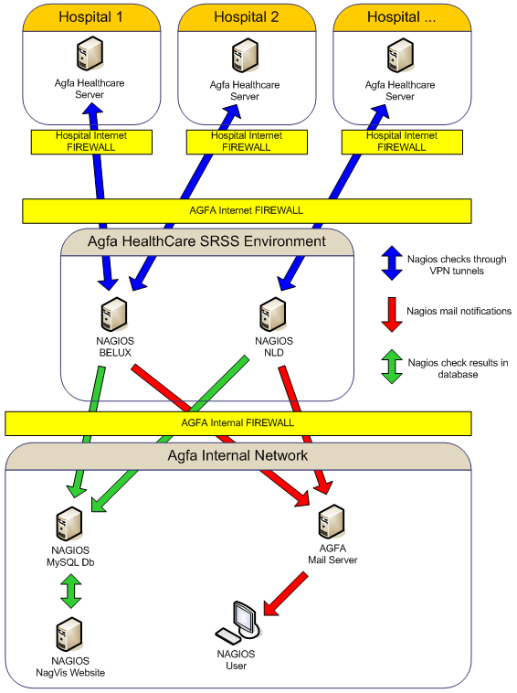

### Service Approach

*Hardware Installation*

* No additional hardware is required. Agents are loaded on each Agfa server

### Agfa Responsibilities

* Provide resources to execute the Service Approach
* Firewall and VPN configuration on the Agfa service side of the connection
* Accurate setup of the database (SNDB) used for Secure Remote Service Support (SRSS)
* Installation of agents on all servers with Agfa software
* Monitoring the dashboard and responding to alerts to provide preventive and remedial support

The installation process, for customers who have existing GRIP monitoring:

* Existing GRIP monitoring agents, server and alerts will remain in place.
* Agents will be added to all Enterprise Imaging core servers, RIS servers, Cardiology Servers

Note: no server reboots should be required for the installation

* Alert testing and threshold fine turning
* Collect feedback on the new monitoring system
  + Customer feedback
  + Number of pro-active resolutions
  + Equipment uptime
* After 30-60 days a determination will be made if it is appropriate to remove SMMS alerts if they are being replaced

### Customer Responsibilities

#### Assistance as needed with IP addresses, passwords, etc to provide direct connections via SNDB and via SRSS to servers

* + - Note: Installation of the agents requires direct connections to each server (or virtual server) to be monitored. Access from another server or through a proxy does not provide the technical ability to load the monitoring agents or do the monitoring. A customer site pre-requisite form will need to be completed.

#### Firewall Ports

#### Summary

* + ICMP Regular PING command to a defined host
  + TCP104 -> Check to wfm to verify dicom communication is allowed. (DICOM PING)
  + UDP 161 -> SNMP traffic that will be checked for system parameters.
  + TCP2301 -> HP port to verify if the HP management home page is running
  + TCP2381 -> HP port to communicate with HP management home page
  + TCP5666 -> NRPE port where NRPE agent is running on

If HP servers are to be monitored also -

* + TCP5988 -> HP SIM communication
  + TCP5989 -> HP SIM communication
  + TCP7920 -> HP communication

#### Protocol, Port number, Direction, Destination and Reason for the basic messages

**ICMP NA Inbound network address 134.54.122.49**

Check that the host is alive and the response time

**TCP 104 Inbound network address 134.54.122.49**

Verify DICOM communication to each workflow manager (DICOM PING)

**UDP 161 Inbound network address 134.54.122.49**

SNMP traffic to check System CPU / MEM

**TCP 5666 Inbound network address 134.54.122.49**

NRPE agent port. Used to communicate directly with Nagios for Script results

#### Additional Optional HP HW Monitoring

**TCP 2301 Inbound network address 134.54.122.49**

Checks to this port ensure that the HP agents and system Management Home page is running

**TCP 2381 Inbound network address 134.54.122.49**

Used to transmit Hardware status information

**TCP 5988 Inbound network address 134.54.122.49**

Checks if the HP Management agents are running

**TCP 5989 Inbound network address 134.54.122.49**

Communication for the HP agents runs over this port

**TCP 7920 Inbound network address 134.54.122.49**

Communication for HP EVA storage to communicate status and errors

**Customer Contact**

A contact at the customer site is needed to assist with VPN and firewall configuration changes. Also an email list of those who want to be contacted when the monitoring configuration has been completed should be provided to the project manager.

### Deliverables

* GRIP New site request
* A customer site pre-requisite form will need to be completed

The customer Project Manager will be requested to acknowledge the completion of the GRIP Deployment Service by signature of *Clinical Acceptance Test Plan*.

# SOW ACCEPTANCE

|  |  |
| --- | --- |
| Customer | Agfa HealthCare |
| Project Sponsor | Project Sponsor |
|  |  |
| Signature | Signature |
|  |  |
| Date | Date |
|  |  |